
Cambodia Academy of Digital Technology
Institute of Digital Technology

CAPSTONE PROJECT I REPORT ON
“Vision Care AI”

Authors of Project:
Houng Sokleng, Eang KimChhiv, Hem RithyBondeth
Koy Sambo, Hul Sambath, Hang Rithratana

Under the advisory of
Mr. Ang MengChhuong
Date of defense: September 25, 2024

ACKNOWLEDGEMENT

We would like to express our thankfulness and appreciation toward all individuals and organisations which have been involved in guiding us toward the successful completion of this Re-Capstone 1 program.

Initially, We want to thank and express my gratitude to the Cambodia Academy of Digital Technology for providing us an opportunity to have a chance to work and explore more in the program.

His Excellency Dr. Seng Sopheap, President of the Cambodia Academy of Digital Technology (CADT), for his hard-working, good leadership and for giving us the chance to pursue our goal and future.

His Excellency Hean Samboeun, Vice President of Cambodia Academy of Digital Technology (CADT), dedicated his time to monitor and organize the institution.

I am so grateful to Mr. Ang MengChhuong, our advisor, for helping us in our capstone project process. Thanks for guiding us toward the right path, providing advice to solve many problems which we had countered, and always coordinating our problem with the school.

Lastly, we would like to extend my heartfelt appreciation to everyone who has contributed in this period.

ABSTRACT

This project provides a detailed approach to detecting eye diseases using advanced machine learning and image processing methods. We have developed a reliable system that utilizes deep learning algorithms to analyze retinal images and accurately detect a range of eye conditions, including diabetic retinopathy, glaucoma, cataracts, and normal eye states. This system aims to improve early diagnosis and treatment, contributing to better eye health outcomes.

A convolutional neural network (CNN) that has been trained on a sizable dataset of label retinal images. To improve accuracy and lower the false positives and negatives of the systems, the model needs to be modified by using the cleaning and resizing images throughout the training phase and testing on many models techniques in order to find the best performance model to ensure the reliability of the system.

The results demonstrate that the methods used had achieved a good accuracy in detecting eye disease which outperformed the traditional diagnosis methods. The project not only illustrates the potential of deep learning and artificial intelligence in the medical sectors but also provides an important need for early detection to avoid any serious vision loss. For future work, we plan to focus on expanding the dataset, improving the model, and expanding the scope of eye diseases.

TABLE OF CONTENTS

ACKNOWLEDGEMENT 1
ABSTRACT 2
TABLE OF CONTENTS 3
LIST OF FIGURES 6
LIST OF TABLES 8
LIST OF ABBREVIATIONS 9
I. GENERAL PRESENTATION 10
1.1. Project Presentation 10
1.1.1. Project Organization 10
1.1.2. Project Overview 10
1.1.3. Problems 11
1.1.4. Objectives 11
1.2. Software Development Life Cycle 12
1.3. Project Scope 13
1.4. Task Breakdown 14
1.5. Project Planning 15
II. ANALYSIS AND SPECIFICATION OF REQUIREMENT 16
2.1. Case Study of Requirements 16
2.1.1. Functional Requirements 16
2.1.2. Non-functional Requirements 18
2.2. System Design 20
2.2.1. Use Case Diagram 20
2.2.1.1. User Use Case (Mobile App) 20
2.2.1.2. User Use Case (Website) 21
2.2.2. Activity Diagram 22
2.2.2.1. Mobile App 22
2.2.2.2. Web Application 23
III. TECHNOLOGY AND DESIGN 24
3.1. Choice of Technology 24
3.1.1. Technologies 24
3.1.2. Development Tools 26
3.1.3. Communication Tools 29
IV. LITERATURE REVIEW 31
V. Methodology 34
5.1. Project Setup 34
5.1.1. Data Collection 34
5.1.2. Data Preprocessing 36
5.2. Model Selection 37
5.3. Model Architectures Detail 37
5.3.1. ResNet50 37
5.3.2. VGG16 38
5.3.3. DenseNet 40
5.4. Training Process 42
5.5. Evaluation 43
5.5.1. ResNet50 44
5.5.1.1. Evaluation of training 4 classes before resized 44
5.5.1.2. Evaluation of training 4 classes after resized 46
5.5.2. VGG16 48
5.5.2.1. Evaluation of training 4 classes before resized 48
5.5.2.2. Evaluation of training 4 classes after resized 49
5.5.3. Evaluation after training 3 classes after resized 51
5.5.4. DenseNet 52
5.5.4.1. Evaluate the 4 classes 52
5.5.4.2. Evaluate the 3 classes 54
5.6. Conclusion 55
VI. Project Implementation 57
6.1. Project Setup 57
6.1.1. Laravel Project Setup 57
6.1.1.1. Backend Design Pattern (MVC) 58
6.1.2. Flask Python Setup 59
6.1.3. Flutter Project Setup 59
6.1.4. React.js Project Setup 60
6.2. System Structure 62
6.2.1. Laravel Project 62
6.2.2. Flask Project 64
6.2.3. Structure of the Application 65
6.2.4. React.js Project 70
6.3. Implementation 70
6.3.1. API Integration 70
6.3.1.1. API Protection and Security Measures 71
6.3.1.3. API Integration 71
6.3.2. Mobile Integration 75
6.3.2.1. Architecture of Application 75
6.3.2.2. Architecture Pattern of Application 76
6.3.3. Web Client Integration 76
6.3.3.1. Architecture of Web Application 76
VII. Conclusion 78
7.1. Result 78
7.2. Strong Points 80
7.3. Weak Points 80
7.4. Experiences 80
7.5. Difficulties 81
7.6. Perspective 81
7.7. Conclusion 82
REFERENCES 83
APPENDICES 85

LIST OF FIGURES
Figure 1: Project Organization 11
Figure 2: Scrum Methodology 14
Figure 3: Use Case Diagram (Mobile App) 21
Figure 4: Use Case Diagram (Mobile App) 22
Figure 5: Activity Diagram (Mobile App) 23
Figure 6: Activity Diagram (Website) 24
Figure 7: Figma Logo 25
Figure 8: Laravel Logo 25
Figure 9: MySQL Logo 26
Figure 10: Python Logo 26
Figure 11: Flutter Logo 26
Figure 12: React.js Logo 27
Figure 13: Visual Studio Code Logo 27
Figure 14: XAMPP Logo 28
Figure 15: GitHub Logo 28
Figure 16: Postman Logo 28
Figure 17: phpMyAdmin Logo 29
Figure 18: Draw.io Logo 29
Figure 19: Colab Logo 29
Figure 20: Jupyter Logo 30
Figure 21: Telegram Logo 30
Figure 22: Google Meet Logo 31
Figure 23: Discord Logo 31
Figure 24: Generate image from Bing AI 35
Figure 25: Disease Folders 36
Figure 26: Normal Eye Image 36
Figure 27: Cataract Disease Image 36
Figure 28: Diabetic_retinopathy Disease Image 37
Figure 29: Glaucoma Disease Image 37
Figure 30: ResNet50 Model Architecture 39
Figure 31: VGG16 Model Architecture 40
Figure 32: VGG16 Architecture Map 40
Figure 33: Densenet Architecture 42
Figure 34: Precision Formula 44
Figure 35: Recall Formula 44
Figure 36: F1 Score Formula 45
Figure 37: Confusion Matrix of ResNet50 before resized 46
Figure 38: Confusion Metric of ResNet50 after resized 47
Figure 39: Confusion Metric of VGG16 before resized (4classes) 49
Figure 40: Confusion Metric of VGG16 after resized (4 classes) 51
Figure 41: Confusion Metric of VGG16 after resized (3classes) 52
Figure 42: Confusion Matrix of DenseNet (4 classes) 54
Figure 43: Confusion Matrix of DenseNet (3 classes) 55
Figure 44: MVC Pattern 60
Figure 45: Laravel Project Structure 63
Figure 46: Flask Project Structure 65
Figure 47: Mobile App Project Structure 66
Figure 48: Dependencies of Mobile App 70
Figure 49: React.js Project Structure 71
Figure 50: Architecture of Application 76
Figure 51: Architecture Pattern of Application 77
Figure 52: Architecture of Web Application 78

LIST OF TABLES
Table 1: Scrum Table 11
Table 2: Task Breakdown 13
Table 3: Project Planning 14
Table 4: Functional Requirement Table 17
Table 5: Non-Functional Requirement Table 18
Table 6: Hyperparameter in Experiment 42
Table 7: Evaluation table of ResNet50 after resized 45
Table 8: Evaluation table of VGG16 before resized (4lasses) 47
Table 9: Evaluation table of VGG16 after resized (4 classes) 48
Table 10: Evaluation table of VGG16 after resized (4 classes) 50
Table 11: Evaluation of DenseNet Table (4 classes) 51
Table 12: Evaluation of DenseNet Table (3 classes) 53
Table 13: DenseNet on 3 classes (Tensorflow) 54
Table 14: Completed Task Table 78
Table 15: Uncompleted Task Table 79

LIST OF ABBREVIATIONS
AI : Artificial intelligence
API : Application Programming Interface
CNN : Convolutional Neural Network
CRUD : Create, Read, Update, Delete
VGG : Visual Geometry Group
HTTP : Hypertext Transfer Protocol
ML : Machine Learning
MSE : Mean Square Error
MVC : Model, View, Controller
MVVM : Model-View-ViewModel
SDLC : Software Development Life Cycle
UI : User Interface
URL : Uniform Resource Locator

GENERAL PRESENTATION
This report presents a comprehensive overview of a mobile application designed to enhance eye health consultations through the integration of machine learning technology. The application focuses on diagnosing common eye diseases, namely Glaucoma, Cataracts, and Diabetic Retinopathy, utilizing image classification techniques to analyze photographs of users' eyes.

Project Presentation
In the Project Presentation section, we will explore the team involved in development, highlight the application’s goal, discuss the challenges related to eye health access and we will present the project’s objectives.

Project Organization

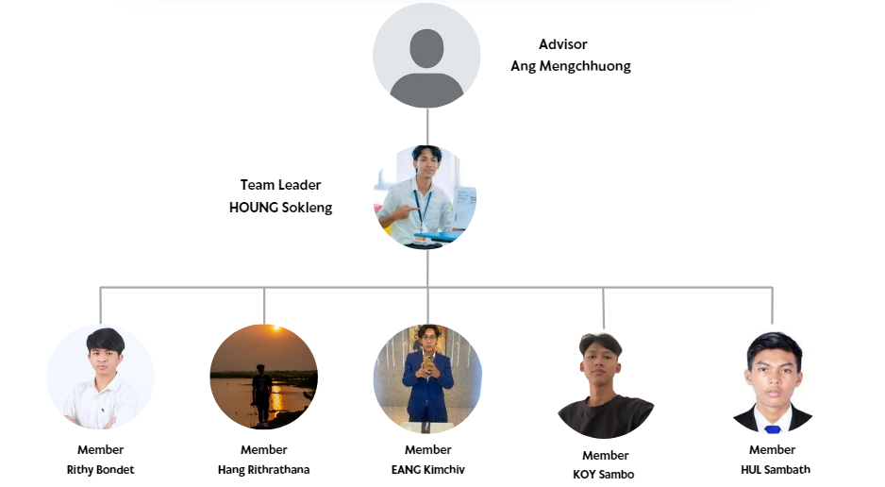
Figure 1: Project Organization

Project Overview
This project aims to develop a mobile application that integrates with machine learning to provide a consultancy service for diagnosing eye diseases. The primary focus is on four conditions: Glaucoma, Cataracts, Diabetic Retinopathy, and Normal Eye. The application will use image classification to analyse photos of users' eyes, helping them to identify potential issues. Additionally, it will give users comprehensive details about each sickness, enabling them to better understand their conditions and take the necessary action. This solution, which provides convenient and trustworthy eye health consultations via mobile devices, is specifically made to help the people of Cambodia.

Problems
Eye diseases such as Glaucoma, Cataracts, and Diabetic Retinopathy are prevalent and can lead to severe visual impairment or blindness if not detected and treated early. In Cambodia, access to specialised eye care and diagnostic services is often limited, particularly in rural areas. Even when individuals visit healthcare providers, they may leave with unclear information about their condition or without a comprehensive understanding of the disease.

This lack of clarity and detailed information can cause nervousness and confusion, preventing individuals from taking the necessary steps to maintain their eye health. A trustworthy and easily available resource that can offer more details and comfort regarding eye diseases is urgently required so that people can better understand their illnesses and make health-related decisions.

Objectives
The primary objective of this project is to create a user-friendly mobile application that acts as a consultant for eye health, providing additional information and reassurance to users about potential eye diseases. The specific objectives are:
- Enhanced Understanding: To help users gain a clearer understanding of their eye conditions, especially after receiving uncertain or insufficient information from healthcare providers.
- Educational Resource: To educate users about Glaucoma, Cataracts, Diabetic Retinopathy, and Normal Eye conditions, including symptoms, risk factors, and treatment options, empowering them to make informed decisions about their eye health.
- Accessibility: To ensure that people in Cambodia, especially in remote and underserved areas, have access to reliable eye health information and consultations without the need for specialised equipment or in-person visits.
- Improved Health Outcomes: To contribute to the reduction of anxiety and confusion related to eye health by providing detailed and accessible information, thereby encouraging timely medical intervention and better eye health management.

Software Development Life Cycle
In this project, we use Scrum methodology to manage. Why do we use Scrum?
- Iterative and Incremental Delivery: Scrum breaks down the project into smaller chunks called Sprints (usually 2-4 weeks). This allows for delivering working features at regular intervals and incorporating feedback early and often.
- Adaptability: Scrum is flexible and allows you to adjust to changing requirements during the project. This is particularly useful for projects with some unknowns or where stakeholder needs might evolve.
- Increased Visibility: Regular meetings and a focus on transparency keep stakeholders informed of progress and potential roadblocks. Improved Quality: Continuous integration and testing throughout Sprints lead to a higher quality product.
- Enhanced Risk Management: Scrum allows for early detection and mitigation of risks through regular reviews and adaptations.

Scrum Master | Product Owner | Developer | ML Engineering
- Mr. | - Houng Sokleng | - Hul Sambath  - Koy Sambo  - Rithy Bondeth  - Hang Rithratana | - Eang Kimchhiv
Table 1: Scrum Table

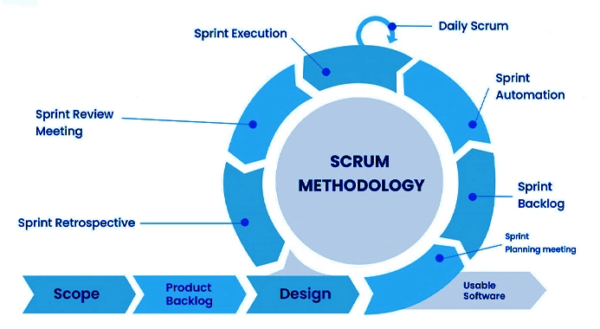
Figure 2: Scrum Methodology

Project Scope
The project aims to further develop and enhance the functionalities of the existing Capstone II project, focusing on improving the user experience, adding new features, and advancing the eye disease detection model. The key areas of development include:
- Update UI
  - Redesign and update the current user interface for improved usability and make it looks good
- Feature Development
  - Create and implement new features to support better functionality for users
- Website Development
  - Develop a website that users can access from any browser to detect eyes disease
- Model Improvement and Accuracy Enhancement
  - Improve the accuracy of the existing model for detecting eye diseases
  - Test and validate the model to ensure reliable detection of various eye diseases
- Offline Detection Model
  - Develop and implement a new model that allows the system to detect eye diseases in offline mode.

Task Breakdown
Role | Responsible | Technology
UX/UI Designer | - Hang Rithratana | Figma
Web Developer | - Rithy Bondeth  - Houng Sokleng | React JS
Mobile Developer | - Hul Sambath  - Houng Sokleng  - Koy Sambo | Flutter, MVVM, Provider
Backend Developer | - Houng Sokleng  - Koy Sambo | Flask API  MySQL, Laravel
Data Trainer | - Eang Kimchhiv | Python, Pytorch, Tensor Flow

Table 2: Task Breakdown

Project Planning
Below is a table outlining our planned activities:

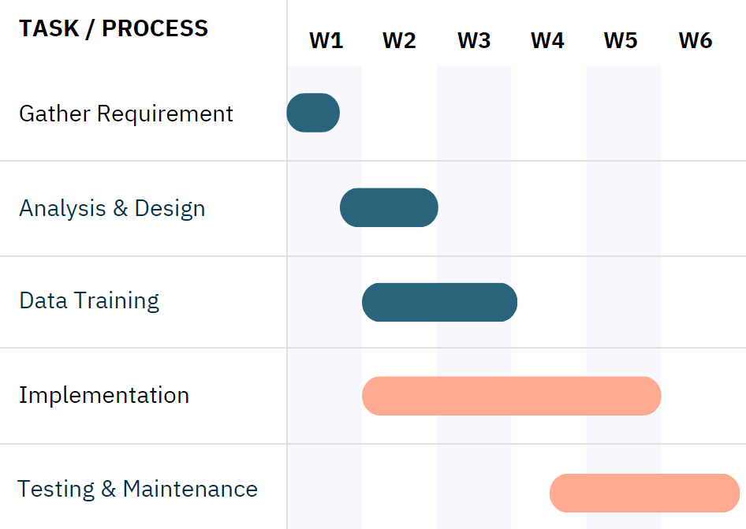
Table 3: Project Planning

- Gather Requirement: Define scope project like functional or non-functional.
- Analysis & Design: We discuss and design the static UI on Figma.
- Data training: We chose the model then trained with the data.
- Implementation: We develop the mobile application, admin dashboard, backend, Flask API, and improve model training.
- Testing & Maintenance: After integrating the machine learning model with a mobile application, we test and fix the error to improve and make sure it works well.

ANALYSIS AND SPECIFICATION OF REQUIREMENT

Case Study of Requirements
In this case study, the system has many requirements that need to be fulfilled for our users. These requirements can be divided into two main types: functional requirements and non-functional requirements.

Functional Requirements
The functional requirements represent the essential core functionalities that must be thoroughly implemented to ensure the proper operation and success of our application.. The details of these functionalities are as follows:

Functionality |  | Description | Assignee
Mobile | Enhance App Theme | Update the app's colour scheme to the Material 3 colour system. The Material 3 design system offers a modern, simple design concept that looks friendly and approachable. | Hul Sambath
Mobile | Enhance App Theme | Update the app's font from the Poppins family to Noto Serif Khmer. | Hul Sambath
Mobile | Offline Mode | Check the network connection when the user opens the app and monitor for changes in network status. | Hul Sambath
Mobile | Offline Mode | Disease Detection in Offline Mode: When there is no network connection, users can still detect diseases using the TensorFlow Lite model within the app. | Hul Sambath
Mobile | Doctor Appointment | Display a list of clinics and doctors available in our system. | Hul Sambath
Mobile | Doctor Appointment | Provide users with clinic details, including the number of doctors, specialties, location, experience, licence information, and a few clinic posters. | Koy Sambo
Mobile | Doctor Appointment | Allow users to look for or appoint a doctor who specialises in their disease, so they spend less time to find the doctor. | Koy Sambo
Web (Clinic) | View Dashboard | clinic can access to dashboard that provides an overview of total number of doctors, admitted patients and readmitted patients | Koy Sambo
Web (Clinic) | Mange Doctor | Clinic can manage doctor profiles by add, update and delete | Koy Sambo
Web (Clinic) | Respond to appointment Request | Clinic can handle appointment requests from users by either accepting or rejecting the request | Koy Sambo
Web (User) | Authentication | Implement secure user authentication allowing users to sign in using their email and password. | Houng Sokleng
Web (User) | User Registration | Enable new users to register by providing first name, last name, phone number, email, and a profile image. | Hem Rithybondeth
Web (User) | Reset Password | Allow users to reset their password in case they forgot the password. | Hem Rithybondeth
Web (User) | Edit User Profile | Provide users the ability to edit their profile information, including name, phone number, email, and profile image. | Hem Rithybondeth
Web (User) | Dark/Light Theme | Add a feature that lets users switch between a dark and light theme for better accessibility and user experience. | Hem Rithybondeth
Web (User) | Visioncare News Section | Display a news section that pulls in the latest articles or updates related to eye care, eye health, and advancements in vision care technology. | Hem Rithybondeth
Web (User) | AI Disease Detection | Provide an interface where users can upload an image of their eye. The image will be analysed by the AI-powered detection system to identify potential eye diseases. | Hem Rithybondeth
Web (User) | AI Detect Incorrect Image | The AI can validate the images that users upload. If the image is not of an eye, it cannot detect any diseases. | Hem Rithybondeth
Web (User) | Save/Delete AI Detection History | Users can save or delete their eyes detection after they upload an image to detect the disease. | Hem Rithybondeth
Web (User) | Send Email | Implement a contact form that allows users to send emails directly to the website for inquiries or support. | Hem Rithybondeth

Table 4: Functional Requirement Table

Non-functional Requirements

Non-functional Features | Requirement
UX/UI | The UX/UI is very simple and user-friendly for both normal users and admin
Performance | All steps in the development of a new intranet must always consider the impact of performance because it is vital that our system runs quickly and efficiently without any errors.
Maintainability | The system must be designed and programmed in a way that is easy and hassle-free for the next developers to maintain
Scalability | The system architecture must be carefully designed regarding the scalable nature so that new changes or adjustments can be performed in the future seamlessly and effectively
Table 5: Non-Functional Requirement Table

System Design

Use Case Diagram

User Use Case (Mobile App)
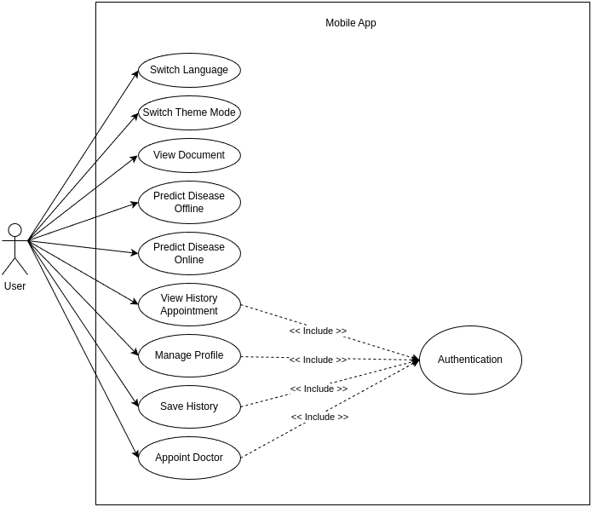
Figure 3: Use Case Diagram (Mobile App)

User Use Case (Website)
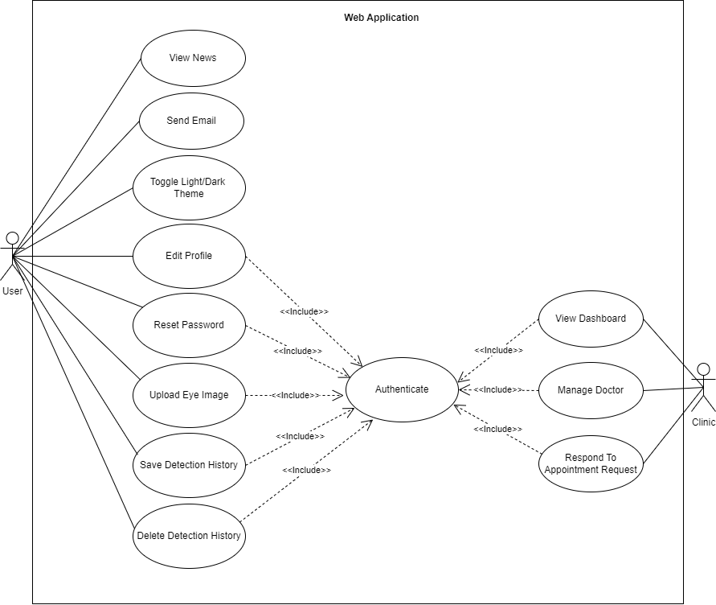
Figure 4: Use Case Diagram (Mobile App)

Activity Diagram

Mobile App
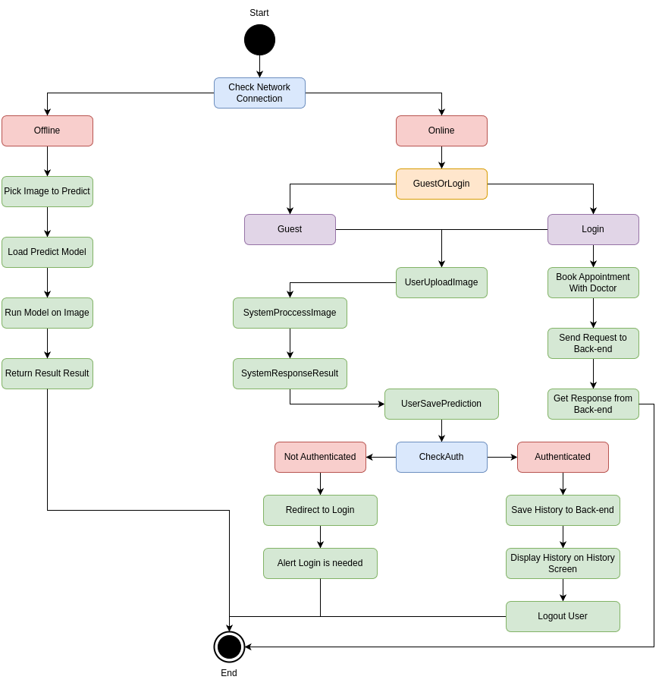
Figure 5: Activity Diagram (Mobile App)

Web Application
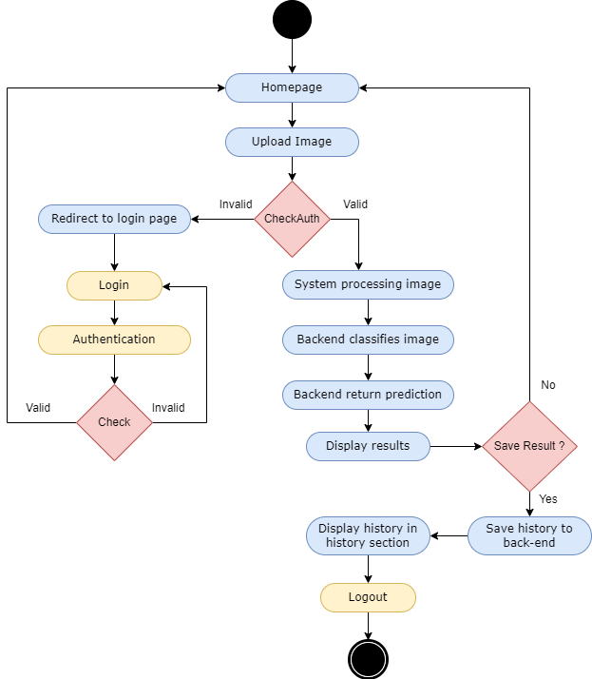
Figure 6: Activity Diagram (Website)

TECHNOLOGY AND DESIGN

Choice of Technology

Technologies
Figma: is a web-based collaborative design tool used primarily for interface design, prototyping, and collaboration among designers and teams. It allows users to create, edit, and share designs in real-time. Figma is used for creating UI prototypes.

Figure 7: Figma Logo

Laravel: is a web application framework with expressive, elegant syntax. It offers many built-in features that make developing web applications faster and more straightforward. We use laravel as a backend framework.

Figure 8: Laravel Logo

MySQL: is an open-source relational database management system. It’s easy for us to manage the database.

Figure 9: MySQL Logo
Python is a versatile, high-level programming language known for its readability and ease of use, making it ideal for data analysis, machine learning, and automation. We use it due to it having a large standard library and vast ecosystem of third party packages.

Figure 10: Python Logo

Flutter is an open source framework by Google for building beautiful, natively compiled, multi-platform applications from a single codebase. We use flutter to develop mobile apps. It provides good performance and has a wide range of tools for building attractive user interfaces. The hot reload feature helps us see changes immediately without restarting the app.

Figure 11: Flutter Logo

React.js is a popular JavaScript library for building user interfaces, particularly single-page applications. It allows developers to create reusable UI components that manage their own state, making it easier to build complex, dynamic web applications.
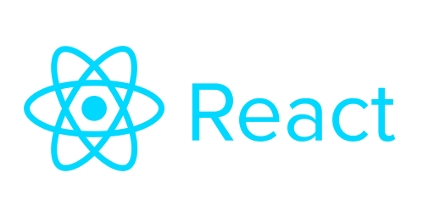
Figure 12: React.js Logo

Development Tools
Visual Studio Code: Visual Studio Code is a streamlined code editor with support for development operations like debugging, task running, and version control. It aims to provide just the tools a developer needs for a quick code-build-debug cycle and leaves more complex workflows to fuller featured IDEs, such as Visual Studio IDE. VS Code is the source code/text editor used to write code for the application.


Figure 13: Visual Studio Code Logo

XAMPP Server: is an open-source software package that provides a local web server environment for testing and development. It helps developers to test web applications locally before deployment, ensuring they function correctly on a live server. XAMPP is used to run the apache and MySQL server.

Figure 14: XAMPP Logo

GitHub: is a web-based platform and version control system that allows developers to collaborate on software projects, track changes to code, manage issues, and host code repositories. GitHub is used for source control or version control for this application.

Figure 15: GitHub Logo

Postman: is a popular API development and testing tool used by developers to interact with APIs (Application Programming Interfaces). It provides an intuitive interface for sending HTTP requests, testing responses, and managing different environments, making it easier to build, debug, and document APIs.
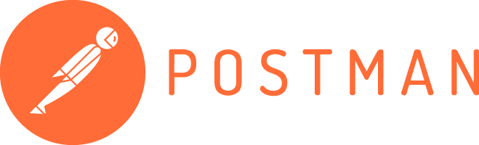
Figure 16: Postman Logo

phpMyAdmin: is a free and open-source web-based application, designed to provide a graphical interface for managing MySQL databases. phpMyAdmin is used to manage the database of the application.
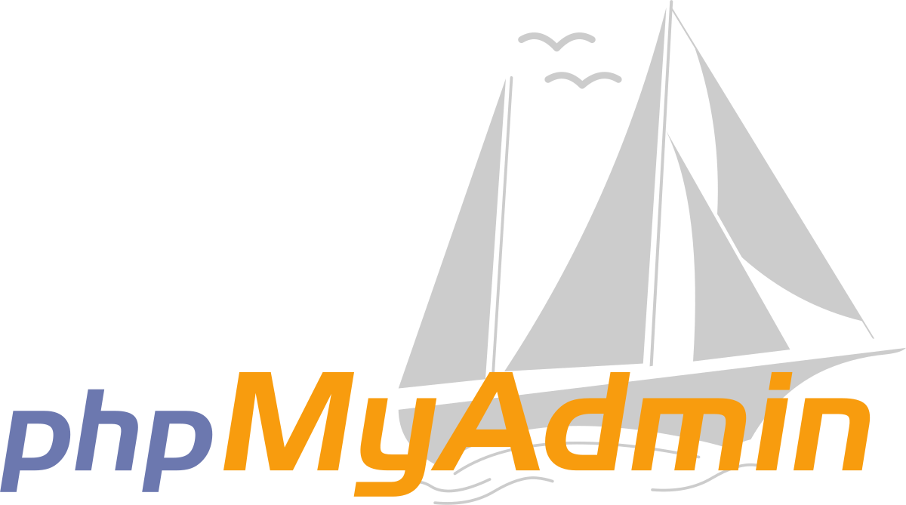
Figure 17: phpMyAdmin Logo

Draw.io: is a web-based diagramming application that allows users to create a wide range of diagrams, such as flowcharts, network diagrams, organisational charts, and more. It provides a simple and intuitive interface that enables users to quickly create and edit diagrams using a variety of shapes and connectors. It is used to draw diagrams for the project.


Figure 18: Draw.io Logo

Colab, or Google Colab, is a free cloud service provided by Google for machine learning and data science tasks. We use this because it allows us to write and execute Python code in a Jupyter notebook environment directly in the browser and have the GPU inside it to make us easily train faster.

Figure 19: Colab Logo
Jupyter Notebook is an interactive tool that allows users to write and execute multiple cells of Python code within a web-based interface, making it ideal for us to train data.

Figure 20: Jupyter Logo

Communication Tools
Telegram: Telegram is a secure messaging and audio calling cloud-based app that allows users to send messages, photos, videos and files of any type to your contacts for free.


Figure 21: Telegram Logo

Google Meet: is a video conferencing platform developed by Google, designed for online meetings, virtual collaboration, and remote communication. Google Meet is used for online meetings.

Figure 22: Google Meet Logo

Discord: is an instant messaging and VoIP social platform which allows communication through voice calls, video calls, text messaging, and media. We use discord for short online meetings.

Figure 23: Discord Logo

LITERATURE REVIEW
Artificial Intelligence, especially Deep Learning and Machine Learning has changed and revolutionised people's lives in many fields with the ability to extract the feature automatically from the raw data. In the concepts of innovation, the deep learning model, particularly CNN, has a potential in assisting and innovating in the medical field such as diagnosing eye disease, brain tumour, or even cancer. Moreover, the Deep learning, CNN, has involved a lot in diagnosing eye diseases such as cataract, glaucoma, normal eyes, and diabetic-neuropathy.

Cataract, symptomized by the dense clouding of the lens which leads to low down vision, is the most common disease that leads to blindness. To detect cataract, the traditional methods are required to take clinical examination and imaging techniques which are a bit challenging and require significant expertise. However, recent studies have used deep learning to automated cataract detection more effectively. A study focused on diagnosing cataract which was CNN-based method by Gao et al. (2017) providing a high accuracy and reliability of detecting the disease from slit-lamp images without the significant need of reliance on expertise interpretation. The model accomplished a high sensitivity over 90% which indicates the potential of deep learning in medical sectors.

A class of eye diseases known as Glaucoma harms the optic nerve and frequently results in permanent blindness which requires early detection for effective medical procedure to avoid significant impact. Tradition diagnose techniques are to use visual field testing, optic nerve head assessment, and intraocular pressure measurement. Li et al.(2018) proposed a deep learning system to analyse the photograph and identify glaucomatous optic neuropathy. The model out performed the traditional method of detecting the glaucoma which received the result of 97%.

In addition, to detect other diseases more effectively and accurately, the normal eyes have to be used to serve as the baseline for comparison. The importance of training on normal eyes class is to accurately identify the crucial parts for reducing the false positives in eye diseases detection. Kermany et al. (2018) developed and published a deep learning model which can detect and classify the classes of normal, glaucoma, diabetic-neuropathic, and cataract with high precision. Their model used a transfer learning approach, leveraging pre-trained networks to improve performance on the relatively smaller ophthalmic image datasets.

Deep learning has many benefits when it comes to vision diagnosis, including increased efficiency, accuracy, and real-time analysis possibilities. But there are still issues with data quality, model understanding, and the requirement for extensive validation across a range of clinical contexts. Ensuring that deep learning models generalise well across different populations and imaging devices is critical for their widespread adoption.

Future studies should concentrate on increasing the adaptability and usefulness of these models, integrating multimodal data, and creating explainable artificial intelligence systems that offer insight into the algorithms' decision-making procedure. Additionally, collaborations between technologists and clinicians are essential to ensure that deep learning tools are seamlessly integrated into clinical workflows, ultimately improving patient outcomes.

These studies' methodologies and models serve as excellent examples of the potential of deep learning in medical diagnostics. Convolutional neural networks (CNNs) were utilised by Gao et al. (2017) to automate the process of feature extraction and achieve excellent sensitivity in the detection of cataracts from slit-lamp pictures. In order to reduce the requirement for specialised interpretation, their method comprised pre-processing the images and teaching the CNN to identify them as cataract or non-cataract. The design was not specified, although it most likely used a conventional CNN methodology for image classification tasks. Other architecture features included the number of layers, types of layers (such as convolutional, pooling, and fully connected), activation functions, and optimization techniques. Similarly, Li et al. (2018) outperformed traditional methods with a 97% accuracy rate when they used a deep CNN to assess optic nerve photos for glaucoma identification. This model learned to identify between glaucomatous and non-glaucomatous optic nerves through training on labeled datasets. A deep Convolutional Neural Network (CNN) was used in the study to classify images. Multiple convolutional layers were probably used in this CNN to capture hierarchical information, and fully connected layers were added for classification. To increase generality, the model probably made use of a lot of labeled samples and methods like data augmentation. By combining transfer learning into their deep learning model and utilising pre-trained networks to identify cataract, diabetic neuropathy, glaucoma, and normal eyes, Kermany et al. (2018) made significant progress in the field. Despite using a very small dataset of ophthalmic images, scientists were able to enhance performance by fine-tuning a model that had been pre-trained on a big dataset. The CNN architecture employed in the study may have been derived from well-known pre-trained models like VGG, ResNet, or Inception. These models have found widespread application in medical imaging investigations and are well-suited for image categorization tasks. Multiple convolutional layers, pooling layers, fully connected layers, and a softmax layer for multi-class classification would all be included in the model. Even with the improvements reported in these studies, there are still a number of issues that must be resolved in order to promote wider clinical adoption. Gao et al. (2017) used CNNs to diagnose cataracts with high sensitivity, although their study may have suffered from a lack of diverse datasets, which might have limited the model's applicability to other populations and imaging technologies. Furthermore, one important aspect of building confidence in clinical settings is the interpretability of the model's conclusions, which is not explored in this work. Li et al. (2018) developed a very accurate model for the detection of glaucoma; however, because the model relies on specific imaging techniques, including optic nerve pictures, its applicability in other clinical contexts where different diagnostic tools are used may be limited. Furthermore, the study did not fully examine the model's performance across a variety of demographic categories, which is essential for ensuring diagnosis fairness and accuracy. Kermany et al. (2018) effectively classified several eye illnesses using transfer learning; however, they did not investigate the influence of using different imaging modalities or devices, which could affect the model's resilience in practical scenarios. Moreover, the study did not address the practical deployment of these models, which requires their integration into current clinical practices. Overall, these gaps suggest the need for more extensive validation, broader dataset inclusion, improved model interpretability, and closer collaboration with clinical practitioners to ensure that deep learning models are both reliable and practical in diverse medical environments.

Methodology

Project Setup

Data Collection
The data for this project was sourced from various platforms, including Kaggle, Google, Bing AI, and other internet sources. The dataset consists of images labelled into four classes: glaucoma, diabetic retinopathy, normal, and cataract. After we combined images from all sources, we got around 500 images in each class.
- Dataset_101: https://www.kaggle.com/datasets/dhirajmwagh1111/dataset-for-different-eye-disease
- Eye Disease Classification: https://www.kaggle.com/datasets/gunavenkatdoddi/eye-diseases-classification
- A global review of publicly available datasets for ophthalmological imaging (in this website there are other website inside it): https://www.thelancet.com/journals/landig/article/PIIS2589-7500(20)30240-5/fulltext
- Search from google
- Using python to generate from bing AI:

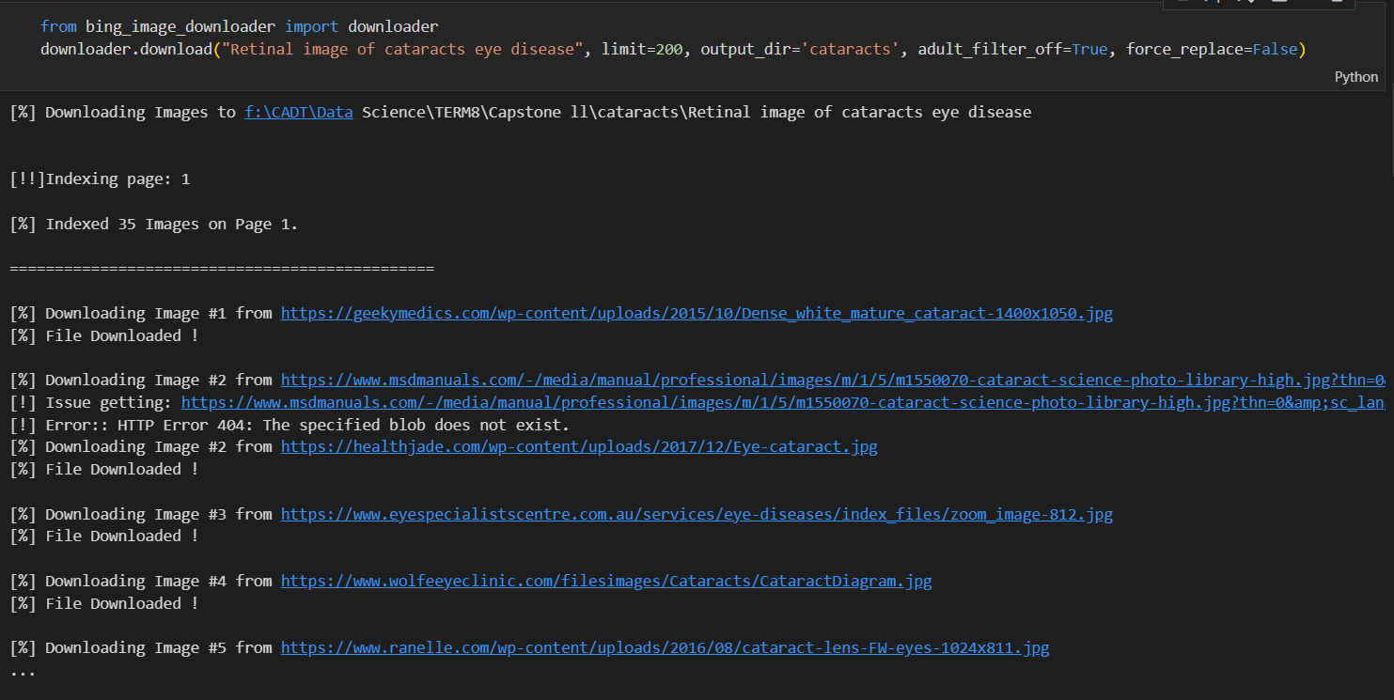
Figure 24: Generate image from Bing AI
Our dataset:

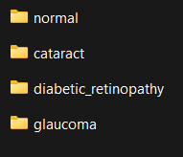
Figure 25: Disease Folders
- Normal:

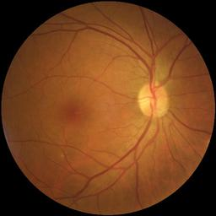
Figure 26: Normal Eye Image
- Cataract:

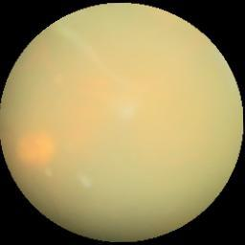
Figure 27: Cataract Disease Image

- Diabetic_retinopathy:

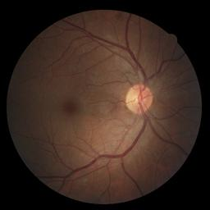
Figure 28: Diabetic_retinopathy Disease Image

- Glaucoma:

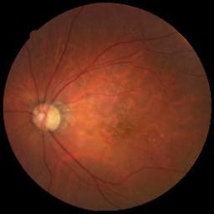
Figure 29: Glaucoma Disease Image

Data Preprocessing
Before training models, we use some preprocessing steps:
- Resizing: All images were resized from the original size to the same size (224 x 224) and rename them then store them in the new folder.
- Cleaning: After resizing, we look at all images then choose only the images that are not suitable to train. Otherwise we removed then we got around 350 - 380 images in each class.
- Normalization: Pixel values were normalized to ensure consistent input ranges.
- Data Augmentation: Techniques such as rotation, horizontalFlip, VerticalFlip, ColorJitter, and transform image to tensor.
- Splitting: The dataset was split into training, validation, and test sets to evaluate model performance. We split data 80% for training, 10% for validation, and other 10% for testing.

Model Selection
We discussed then we decided to choose 3 different models to train and compare for our classification task:
- ResNet50: Chosen for its depth and ability to handle vanishing gradient problems through residual connections.
- VGG16: Selected for its simplicity and effectiveness in image classification tasks.
- DenseNet: Utilized for its dense connectivity, which allows for improved feature propagation and reduced vanishing gradients.

Model Architectures Detail

ResNet50
ResNet50 is a deep convolutional neural network (CNN) architecture that was developed by Microsoft Research in 2015. It is a variant of the popular ResNet architecture, which stands for “Residual Network.” The “50” in the name refers to the number of layers in the network, which is 50 layers deep.

ResNet50 is a powerful image classification model that can be trained on large datasets. The architecture of ResNet50 is divided into four main parts: the convolutional layers, the identity block, the convolutional block, and the fully connected layers. The convolutional layers are responsible for extracting features from the input image, while the identity block and convolutional block are responsible for processing and transforming these features. Finally, the fully connected layers are used to make the final classification.
The convolutional layers in ResNet50 consist of several convolutional layers followed by batch normalization and ReLU activation. These layers are responsible for extracting features from the input image, such as edges, textures, and shapes. The convolutional layers are followed by max pooling layers, which reduce the spatial dimensions of the feature maps while preserving the most important features.

The identity block and convolutional block are the key building blocks of ResNet50. The identity block is a simple block that passes the input through a series of convolutional layers and adds the input back to the output. This allows the network to learn residual functions that map the input to the desired output. The convolutional block is similar to the identity block, but with the addition of a 1x1 convolutional layer that is used to reduce the number of filters before the 3x3 convolutional layer.

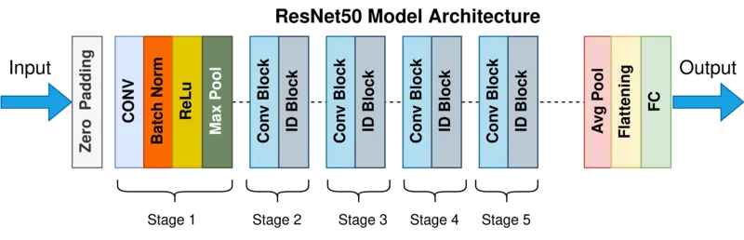
Figure 30: ResNet50 Model Architecture

VGG16
The VGG-16 model is a convolutional neural network (CNN) architecture that was proposed by the Visual Geometry Group (VGG) at the University of Oxford. It is characterised by its depth, consisting of 16 layers, including 13 convolutional layers and 3 fully connected layers. VGG-16 is renowned for its simplicity and effectiveness, as well as its ability to achieve strong performance on various computer vision tasks, including image classification and object recognition. The model’s architecture features a stack of convolutional layers followed by max-pooling layers, with progressively increasing depth. This design enables the model to learn intricate hierarchical representations of visual features, leading to robust and accurate predictions.

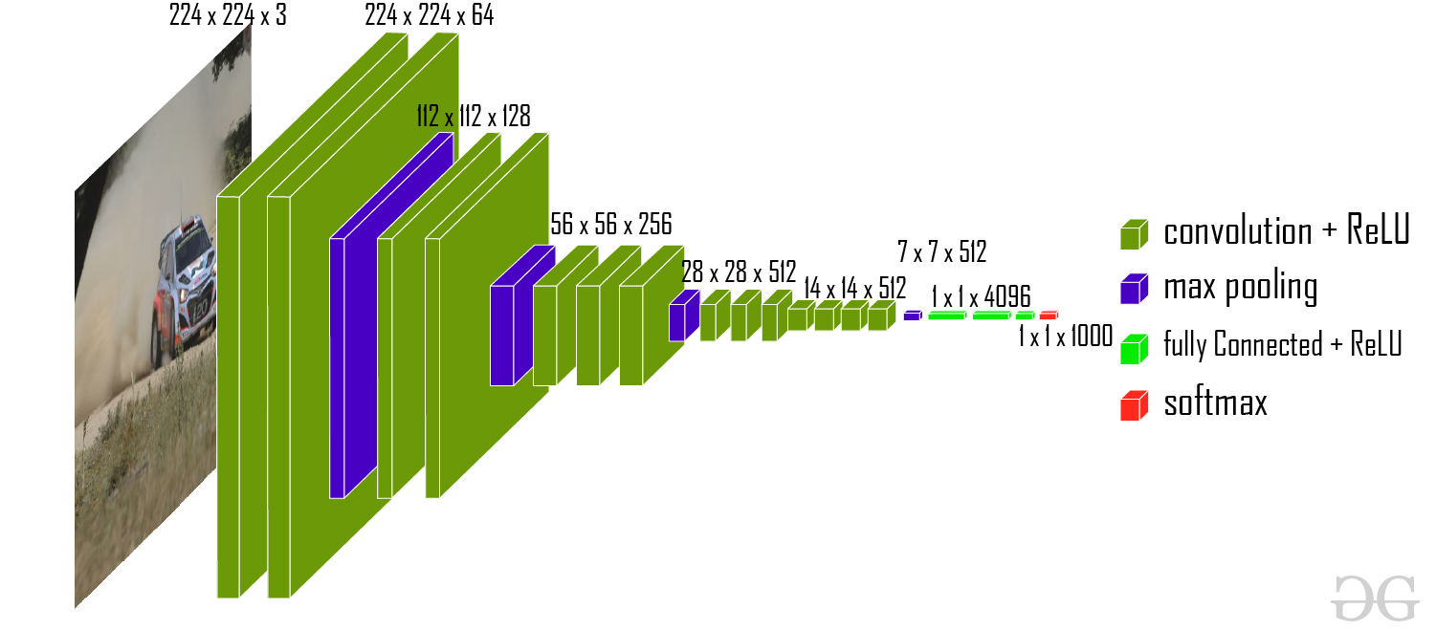
Figure 31: VGG16 Model Architecture
- VGG architecture:

The VGG-16 architecture is a deep convolutional neural network (CNN) designed for image classification tasks. It was introduced by the Visual Geometry Group at the University of Oxford. VGG-16 is characterized by its simplicity and uniform architecture, making it easy to understand and implement.

The VGG-16 configuration typically consists of 16 layers, including 13 convolutional layers and 3 fully connected layers. These layers are organized into blocks, with each block containing multiple convolutional layers followed by a max-pooling layer for downsampling.
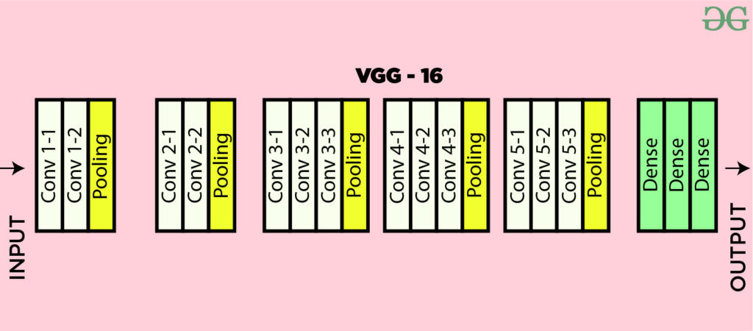
Figure 32: VGG16 Architecture Map
- Input layer: The model accepts images of size 224x224 pixels with 3 colour channels (RGB).
- Convolutional Layers:
  - The network consists of multiple convolutional layers, each followed by a ReLU (Rectified Linear Unit) activation function.
  - Two consecutive convolutional layers with 64 filters each and a filter size of 3×3.
  - Same padding is applied to maintain spatial dimensions.
- Max-Pooling Layers:
  - Max-pooling layer with a pool size of 2×2 and a stride of 2.
  - This helps in reducing the computational complexity and capturing the most important features.
- Fully Connected Layers
  - After the convolutional and pooling layers, the feature maps are flattened into a 1D vector.
  - Three fully connected (dense) layers follow, with 4096, 4096, and 1000 neurons, respectively.
  - The first two fully connected layers have ReLU activations, and the last layer has a softmax activation function for classification.
- Output Layer: The final layer produces a probability distribution over the 1000 classes in the ImageNet dataset.

DenseNet
DenseNet is a deep learning architecture for CNN (convolutional neural networks) or in short it is called Dense Convolutional Network. Densenet was published in 2017 in the paper name “Densely Connected Convolutional Networks” which was introduced by Gao Huang, Zhuang Liu, Laurens van der Maaten, and Kilian Q.Weinberger. DenseNet revolutionised computer vision by addressing problems such as feature reuse, vanishing gradients, and parameter efficiency, and by providing a revolutionary connectivity design inside CNNs. DenseNet establishes a connection directly with all the layers within the block, unlike the other architecture where the layer is only connected to the subsequent layer.
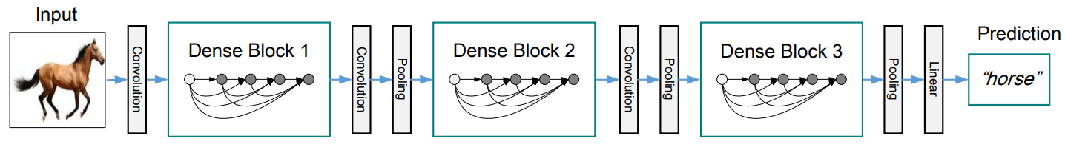
Figure 33: Densenet Architecture
- Architecture
By connecting each layer to each other feed-forward, DenseNet suggests an architectural transformation. Unlike ordinary CNNs, which feature a single link between successive layers, DenseNet ensures that each layer receives inputs from all previous layers and transmits its output to all subsequent layers.

- Dense Block
The fundamental units of DenseNet architectures are dense blocks. Multiple convolutional layers make up each dense block, which are then usually followed by batch normalization and a non-linear activation function. Crucially, feature reuse and propagation are facilitated by the fact that all previous layers' feature maps are fed into each layer inside a dense block.
Every layer in a dense block takes as input the combined output of every layer that came before it. The l-th layer of a dense block with m layers will have k \times (l + l_0) input feature maps (where l_0 is the number of input channels to the dense block) if each layer generates k feature maps (where k is the growth rate).

- Transition Layer
Dense blocks are connected by transition layers. They downsample the three dimensions of space of the feature maps and decrease the quantity of feature maps, which are their two primary functions. This contributes to keeping the network small and computationally efficient.

- Growth Rate
In DenseNet, a crucial hyperparameter is the growth rate (k). It specifies how many feature mappings every layer in a dense block generates. More information is added at each layer with a higher growth rate, but the computational cost goes up as well. The performance and capacity of the network are impacted by the choice of k.

Training Process
In training processing we need to know about the Hyperparameters such as:
- Learning Rate: Determines the step size at each iteration while moving toward a minimum of loss function
- Batch Size: Reder to the number of training samples processed before the model’s internal parameters are updated.
- Optimizer: is the algorithms or methods used to change the attributes of the neural network suzh as weights and learning rate to reduce the losses. There are some types like Adam, SGD…
- Number of Epoch: An epoch is one complete pass through the entire training dataset.
- Loss Function: or we can called it cost function that measures the difference between the predicted output and the actual output. There’re some type like Mean Square Error(MSE), Cross-Entropy, Hing Loss.
In our project we decided to chose models that were trained using PyTorch, with the following hyperparameters:
- Learning Rate: 0.00001
- Batch Size: 32
- Number of Epoch: 75
- Optimizer: Adam optimizer was used for its adaptive learning rate capabilities.
- Loss Function: Cross-entropy loss was employed due to its suitability for multi-class classification tasks.
- EarlyStopping: Early stopping was implemented to prevent overfitting. Training was halted if the validation loss did not improve for 10 consecutive epochs.

Hyperparameter In Our Experiment
Learning Rate | 0.00001
Batch Size | 32
Optimzer | Adam
Loss Function | Cross Entropy

Table 6: Hyperparameter in Experiment

Evaluation
Before we evaluate our model we have to know some important points of evaluation:
- True positives is an outcome where the model correctly predicts the positive class
- True negatives is an outcome where the model correctly predicts the negative class
- False positives is an outcome where the model incorrectly predicts the positive class
- False negatives is an outcome where the model incorrectly predicts the negative class
- Precision is the ratio between true positives versus all positives.
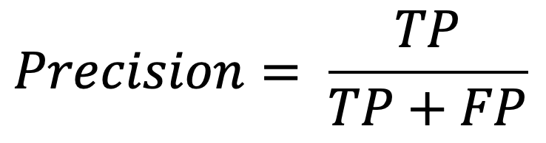
Figure 34: Precision Formula
- Recall is the measure of accurate the model is in identifying true positives.
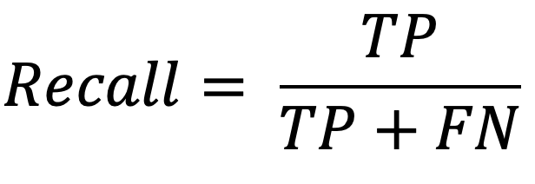
Figure 35: Recall Formula
- The F1 score takes into account both precision and recall and is based on a balance of the two.
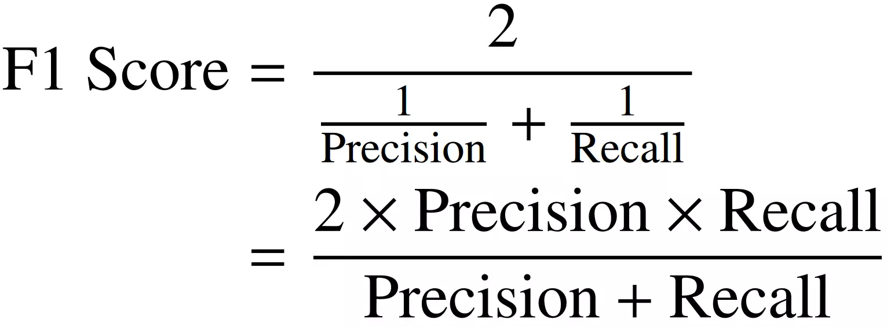
Figure 36: F1 Score Formula

ResNet50

Evaluation of training 4 classes before resized

Class Name | Precision | Recall | F1 Score
glaucoma | 0.37 | 0.61 | 0.46
diabetic_retinopathy | 0.56 | 0.53 | 0.55
normal | 0.46 | 0.27 | 0.34
cataract | 0.89 | 0.73 | 0.80
Accuracy |  |  | 0.54
Table 7: Evaluation table of ResNet50 before resized
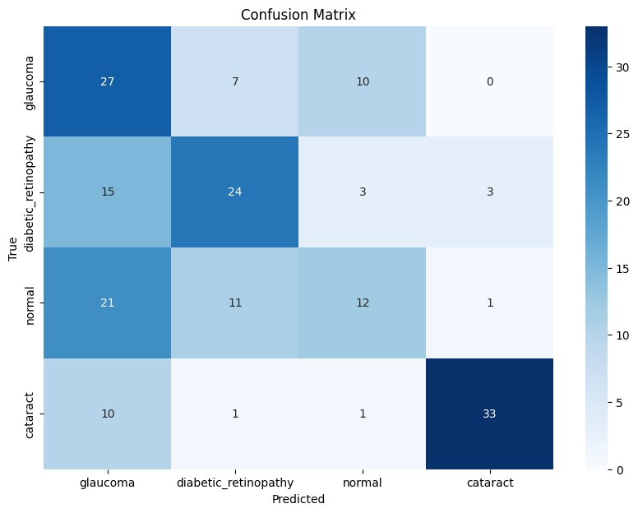
Figure 37: Confusion Matrix of ResNet50 before resized

The above confusion matrix illustrates the information of:
- Glaucoma : it shows the correlation of the glaucoma with the other 3 classes which we can see that the prediction number on the actual and prediction are 27 cases of glaucoma were correctly predicted, 7 cases were predicted wrong as diabetic-retinopathy, and 10 cases were predicted wrong as normal.
- Diabetic-retinopathy: it indicates the prediction of the 4 classes in which 24 cases were predicted correctly, 15 cases were predicted wrongly as glaucoma, 3 classes were predicted incorrectly as normal, and 3 classes were predicted wrongly as cataract.
- Normal: it demonstrates the prediction of the normal class and the other 3 classes in which 12 classes were predicted correctly, 11 classes were predicted wrongly as diabetic-retinopathy, 21 classes were predicted incorrectly as glaucoma, and 1 class was predicted wrongly as cataract.
- Cataract: it presents the prediction of the combination of the 4 classes in which 33 classes were predicted right, 10 classes were predicted wrongly as glaucoma, 1 class was predicted incorrectly as diabetic-retinopathy, and 1 class was predicted incorrectly as normal.

Evaluation of training 4 classes after resized

Class Name | Precision | Recall | F1 Score
diabetic_retinopathy | 0.56 | 0.80 | 0.66
normal | 0.64 | 0.49 | 0.51
glaucoma | 0.75 | 0.65 | 0.70
cataract | 0.90 | 0.97 | 0.94
Accuracy |  |  | 0.71
Table 8: Evaluation table of ResNet50 after resized

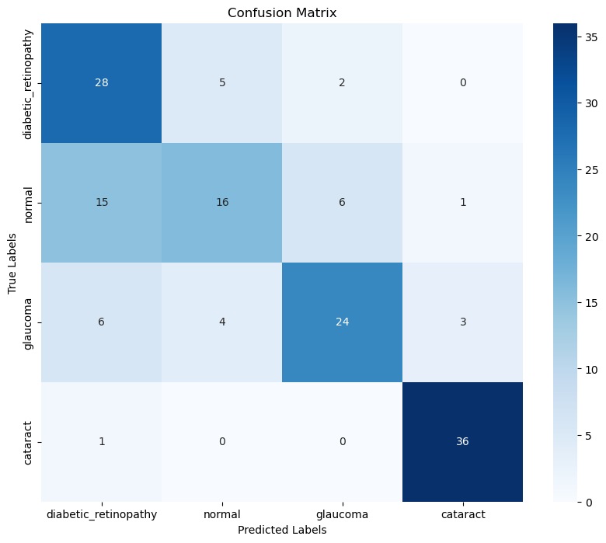
Figure 38: Confusion Metric of ResNet50 after resized
The above confusion matrix illustrates the information of:
- Glaucoma : it shows the correlation of the glaucoma with the other 3 classes which we can see that the prediction number on the actual and prediction are 24 cases of glaucoma were correctly predicted, 6 cases were predicted wrong as diabetic-retinopathy, 4 cases were predicted wrong as normal, and 3 classes were predicted wrong as cataract.
- Diabetic-retinopathy: it indicates the prediction of the 4 classes in which 28 cases were predicted correctly, 2 cases were predicted wrongly as glaucoma, and 5 classes were predicted incorrectly as normal.
- Normal: it demonstrates the prediction of the normal class and the other 3 classes in which 16 classes were predicted correctly, 15 classes were predicted wrongly as diabetic-retinopathy, 6 classes were predicted incorrectly as glaucoma, and 1 class was predicted wrongly as cataract.
- Cataract: it presents the prediction of the combination of the 4 classes in which 36 classes were predicted right, and 1 class was predicted incorrectly as diabetic-retinopathy.

VGG16

Evaluation of training 4 classes before resized

Class Name | Precision | Recall | F1 Score
glaucoma | 0.49 | 0.77 | 0.60
diabetic_retinopathy | 0.92 | 0.49 | 0.64
normal | 0.52 | 0.49 | 0.51
cataract | 0.84 | 0.82 | 0.83
Accuracy |  |  | 0.64
Table 9: Evaluation table of VGG16 before resized (4lasses)
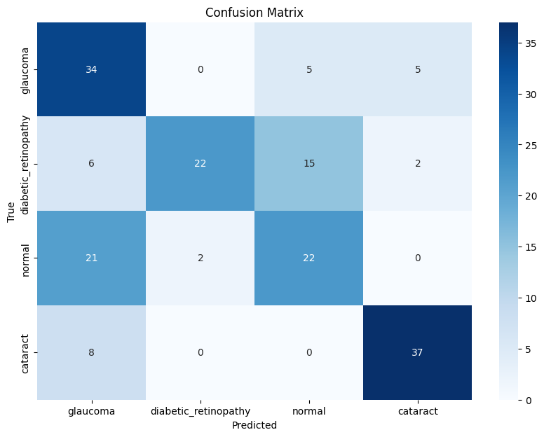
Figure 39: Confusion Metric of VGG16 before resized (4classes)

The above confusion matrix illustrates the information of:
- Glaucoma : it shows the correlation of the glaucoma with the other 3 classes which we can see that the prediction number on the actual and prediction are 34 cases of glaucoma were correctly predicted, 5 cases were predicted wrong as cataract, and 5 cases were predicted wrong as normal.
- Diabetic-retinopathy: it indicates the prediction of the 4 classes in which 22 cases were predicted correctly, 6 cases were predicted wrongly as glaucoma, 15 classes were predicted incorrectly as normal, and 2 classes were predicted wrongly as cataract.
- Normal: it demonstrates the prediction of the normal class and the other 3 classes in which 22 classes were predicted correctly, 2 classes were predicted wrongly as diabetic-retinopathy, and 21 classes were predicted incorrectly as glaucoma.
- Cataract: it presents the prediction of the combination of the 4 classes in which 37 classes were predicted right, and 8 classes were predicted wrongly as glaucoma.

Evaluation of training 4 classes after resized

Class Name | Precision | Recall | F1 Score
diabetic_retinopathy | 0.74 | 0.79 | 0.81
normal | 0.64 | 0.84 | 0.73
glaucoma | 0.40 | 0.22 | 0.29
cataract | 0.97 | 0.97 | 0.97
Accuracy |  |  | 0.71
Table 10: Evaluation table of VGG16 after resized (4 classes)

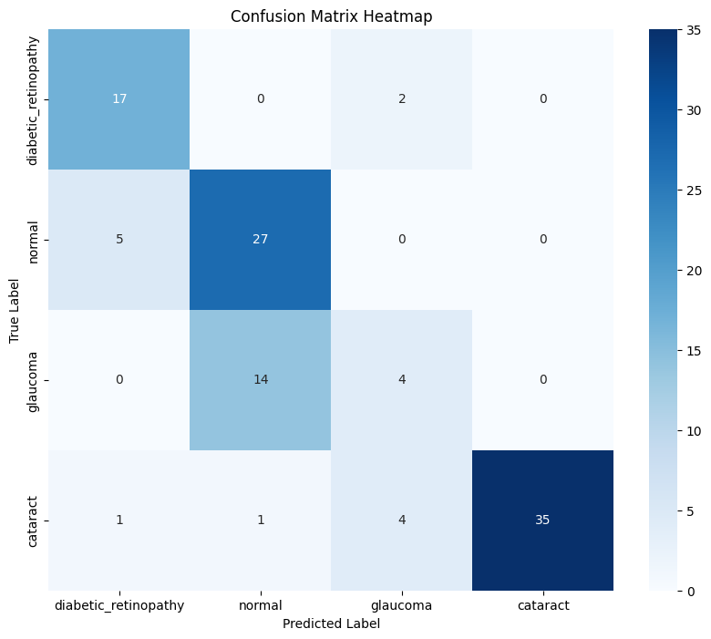
Figure 40: Confusion Metric of VGG16 after resized (4 classes)
The above confusion matrix illustrates the information of:
- Glaucoma : it shows the correlation of the glaucoma with the other 3 classes in which we can see that the prediction number on the actual and prediction are 4 cases of glaucoma were correctly predicted, and 14 cases were predicted wrong as normal.
- Diabetic-retinopathy: it indicates the prediction of the 4 classes in which 17 cases were predicted correctly, and 2 cases were predicted wrongly as glaucoma.
- Normal: it demonstrates the prediction of the normal class and the other 3 classes in which 27 classes were predicted correctly, and 5 classes were predicted wrongly as diabetic-retinopathy.
- Cataract: it presents the prediction of the combination of the 4 classes in which 35 classes were predicted right, 4 classes were predicted wrongly as glaucoma, 1 class was predicted incorrectly as diabetic-retinopathy, and 1 class was predicted incorrectly as normal.

Evaluation after training 3 classes after resized

Class Name | Precision | Recall | F1 Score
diabetic_retinopathy | 0.96 | 0.63 | 0.76
normal | 0.73 | 0.97 | 0.83
cataract | 1.00 | 0.97 | 0.99
Accuracy |  |  | 0.86
Table 11: Evaluation table of VGG16 after resized (4 classes)

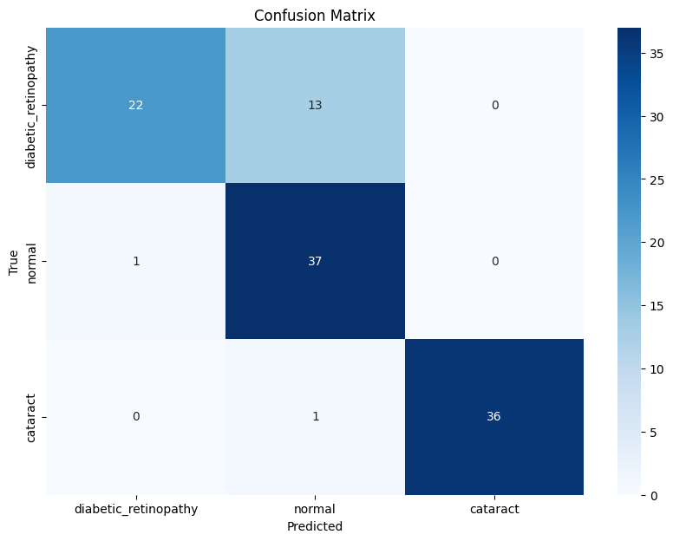
Figure 41: Confusion Metric of VGG16 after resized (3classes)
The above confusion matrix illustrates the information of:
- Diabetic-retinopathy: it indicates the prediction of the 4 classes in which 22 cases were predicted correctly, and 13 classes were predicted incorrectly as normal.
- Normal: it demonstrates the prediction of the normal class and the other 3 classes in which 37 classes were predicted correctly, 1 class was predicted wrongly as diabetic-retinopathy.
- Cataract: it presents the prediction of the combination of the 4 classes in which 36 classes were predicted right, and 1 class was predicted incorrectly as normal.

DenseNet

Evaluate the 4 classes
Class Name | Precision | Recall | F1 Score
diabetic_retinopathy | 0.86 | 0.67 | 0.75
normal | 0.48 | 0.34 | 0.40
glaucoma | 0.52 | 0.78 | 0.63
cataract | 0.88 | 0.92 | 0.90
Accuracy |  |  | 0.67
Table 12: Evaluation of DenseNet Table (4 classes)

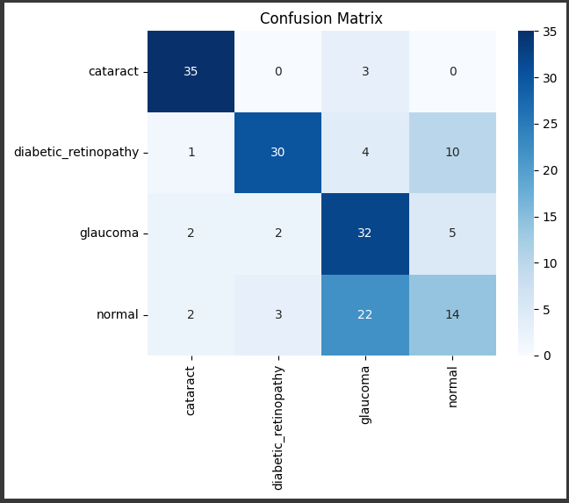
Figure 42: Confusion Matrix of DenseNet (4 classes)
The above confusion matrix illustrates the information of:
- Cataract: it presents the prediction of the combination of the 4 classes in which 35 classes were predicted right, and 0 class was predicted as diabetic-retinopathy, 3 cases were predicted wrongly as glaucoma, and 0 class was predicted incorrectly as normal.
- Diabetic-retinopathy: it indicates the prediction of the 4 classes in which 30 cases were predicted correctly, 4 cases were predicted wrongly as glaucoma, 10 classes were predicted incorrectly as normal, and 1 class was predicted wrong as cataract.
- Glaucoma : it shows the correlation of the glaucoma with the other 3 classes which we can see that the prediction number on the actual and prediction are 32 cases of glaucoma were correctly predicted, 2 cases were predicted wrong as diabetic-retinopathy, 5 cases were predicted wrong as normal, and 2 classes were predicted wrong as cataract.
- Normal: it demonstrates the prediction of the normal class and the other 3 classes in which 14 classes were predicted correctly, 3 classes were predicted wrongly as diabetic-retinopathy, 22 classes were predicted incorrectly as glaucoma, and 2 classes were predicted wrong as cataract.

Evaluate the 3 classes

Class Name | Precision | Recall | F1 Score
diabetic_retinopathy | 0.92 | 0.69 | 0.79
normal | 0.88 | 0.81 | 0.84
cataract | 0.72 | 1.00 | 0.84
Accuracy |  |  | 0.83

Table 13: Evaluation of DenseNet Table (3 classes)

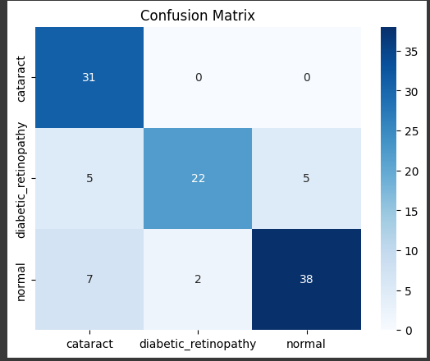
Figure 43: Confusion Matrix of DenseNet (3 classes)

The above confusion matrix illustrates the information of:
- Cataract: it presents the prediction of the combination of the 3 classes in which 31 classes were predicted right, and 0 class was predicted wrong.
- Diabetic-retinopathy: it indicates the prediction of the 3 classes in which 22 cases were predicted correctly, 5 classes were predicted incorrectly as normal, and 5 classes were predicted wrongly as cataract.
- Normal: it demonstrates the prediction of the normal class and the other 2 classes in which 38 classes were predicted correctly, 2 classes were predicted wrongly as diabetic-retinopathy and 7 classes were predicted wrongly as cataract.

5.5.4.3. DenseNet on 3 classes (Tensorflow)

Class Name | Precision | Recall | F1 Score
glaucoma | 0.75 | 0.78 | 0.76
normal | 0.73 | 0.84 | 0.78
cataract | 0.90 | 0.90 | 0.90
Accuracy |  |  | 0.84
Table 14: DenseNet on 3 classes (Tensorflow)
Above table illustrates the result of the model such as:
- Glaucoma : had 75% of precision, 78% of recall, and 76% of f1-score.
- Normal: had 73% of precision, 84% of recall, and 78% of f1-score.
- Cataract: had 90% of precision, 90% of recall, and 90% of f1-score.
- The accuracy of this model is 84%.

Conclusion
Our research tool is designed to classify eye diseases into four categories: Normal, Diabetic Retinopathy, Cataract, and Glaucoma. And we chose the model VGG16 for our tools to predict our online application and web application. It has demonstrated better performance in accurately distinguishing between these classes, providing reliable predictions for these conditions. For the offline mode, we designed the model to classify three different diseases such as Normal, Glaucoma, and Cataract. However, it is important to note that the tool is not designed to detect Diabetic Retinopathy and thus does not provide very accurate results for this specific eye disease. Focussing on Normal, Glaucoma, and Cataract ensures a targeted and successful treatment plan for these common conditions.
There are some constraint and limitation of our current develop research:
- This is my first experience with image classification, requiring extensive research and learning.
- Obtaining real data from hospitals is challenging, which limits the availability of high-quality training and validation datasets. So we decided to choose from the internet.
- Eye disease classification is less commonly explored compared to other fields, limiting the availability of established methodologies and resources.
- A deeper understanding of model architecture and image classification techniques is necessary to improve the model's performance.
- The model may need continuous updates and retraining to adapt to new data and evolving patterns in eye disease detection, which requires ongoing maintenance and resources.

Project Implementation
In this section, we will walk through the step-by-step process of setting up and implementing both the API Server, Client Server for our system and to help you understand how each part is configured.

Project Setup

Laravel Project Setup
To set up and configure a Laravel project, follow these steps:
- Install Laravel: Ensure you have Composer installed. Run the following command to create a new Laravel project:
composer create-project --prefer-dist laravel/laravel eye_disease_backend
- Configure Environment:
.env File: Copy the .env.example file to .env and configure your environment settings (database connection, API keys, etc.):
cp .env.example .env
- Generate Application Key:
php artisan key:generate
- Database Configuration: Update the .env file with your database credentials:
DB_CONNECTION=mysql
DB_HOST=127.0.0.1
DB_PORT=3306
DB_DATABASE=eye_detector
DB_USERNAME=root
DB_PASSWORD=root
- Run Laravel Development Server:
php artisan serve

Backend Design Pattern (MVC)
The MVC design pattern is a popular choice for web applications because it helps to keep the code organised and easy to maintain. It also makes it easier to test the application, as each part of the application can be tested independently.

➢ Model - The model represents the data of the application. It is responsible for storing, retrieving, and manipulating data.

➢ View - The view is responsible for displaying the data to the user. It does not interact with the model directly but instead receives data from the controller.

➢ Controller - The controller is responsible for mediating between the model and the view. It receives requests from the user, updates the model, and then tells the view to display the updated data.
In Laravel, the Model-View-Controller (MVC) pattern is used by default. When a user visits a page in a Laravel application, the browser sends a request to the web server. The web server then forwards the request to the router. The router determines the appropriate controller to handle the request based on the defined routes.
The controller processes the request and interacts with the model to retrieve or manipulate the data required. Once the controller has the necessary data, it passes it to the view. The view then renders the data into a format suitable for display and sends it back to the browser.
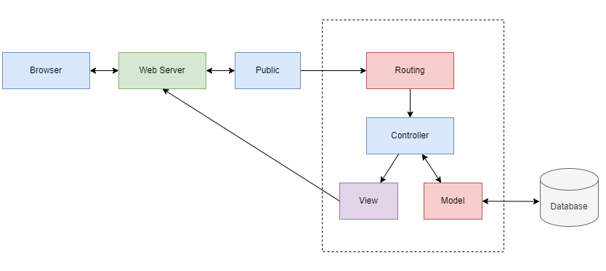
Figure 44: MVC Pattern

Flask Python Setup
This Flask API provides a service for predicting eye diseases using a pre-trained VGG16 model. Users can upload images, and the API will return predictions along with confidence scores.
- Create a Virtual Environment:
python -m venv venv

- Activate the Virtual Environment:
  - Windows:
venv\Scripts\activate
  - macOS/Linux:
source venv/bin/activate

- Install Required Packages:
pip install flask torch torchvision pillow

Flutter Project Setup
Setting up Flutter project step by step:

- Install Flutter:
- Download the Flutter SDK from the official website: www.flutter.dev
- After installation, add the Flutter SDK path to your system's PATH variable.
- Verify Installation:
- Open a terminal or command prompt and run “flutter doctor”
- This command checks your environment and displays a report of any issues.
- Set Up an IDE:
- We use Android Studio as the IDE.
- Install the Flutter and Dart plugins.
- Create a New Flutter Project:
- Open terminal or command prompt
- Run flutter create < project_name > to create a new Flutter project.
- Run the Project:
- Run “flutter run” to build and launch your app on a connected device (emulator or physical device).

React.js Project Setup
Setting up React.js project step by step:

- Install Node.js:
- Download node.js for your operating system (Mac, Window, Linux) from the official website: https://nodejs.org/en
- Once installed, you can check if Node.js and npm are available by running the following commands in your terminal:
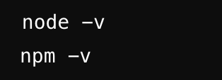

- Setup IDE:
- We use Vscode as the IDE.
- Install Javascript and React.js Snippet Code Extension
- Create a New React App with Vite:
- Open your terminal and run the following command to create a new Vite project:
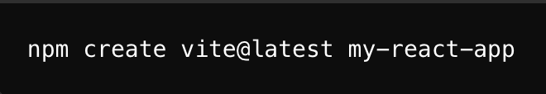
- Choose a framework: Vite will ask which framework you want to use. Select react from the list.
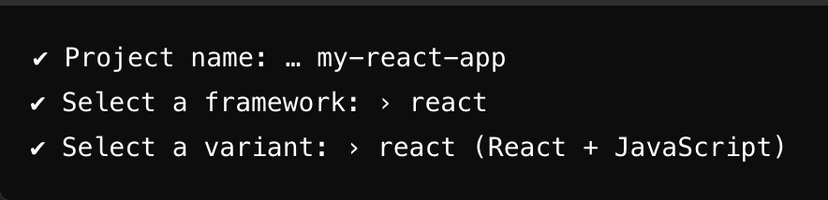
- Run the project
- Once the setup is complete, move into your project folder:
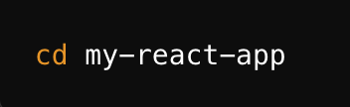
- After creating the project, install the required dependencies by running:
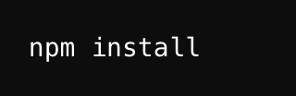
- To start the development server, use the following command:
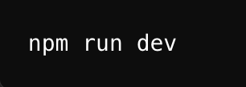
- Vite will start the server on http://localhost:5173/
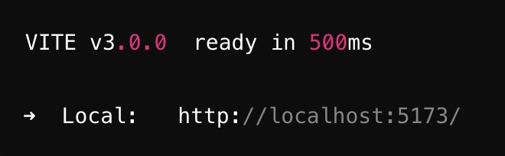

System Structure

Laravel Project
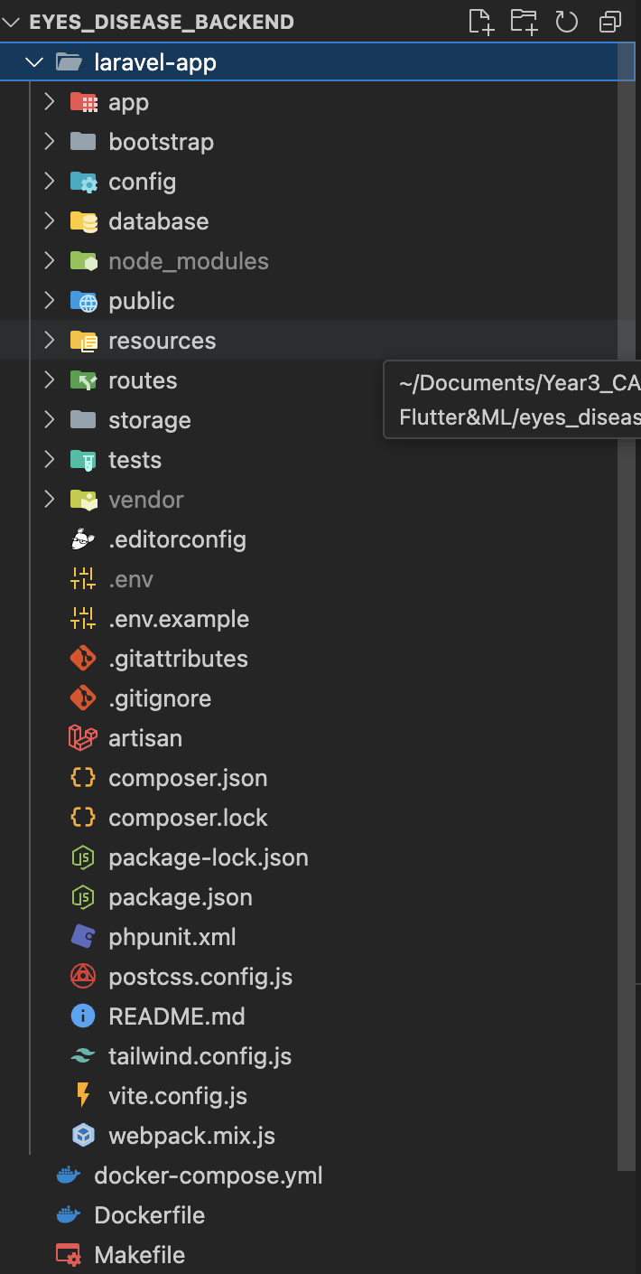
Figure 45: Laravel Project Structure

- App Folder
  - Models: Contains all the Eloquent models. Each model represents a table in the database and provides a way to interact with that table.
  - Http: Includes:
    - Controllers: Handles incoming HTTP requests, processes data, and returns responses. Each controller can manage different aspects of the application.
    - Middleware: Acts as a bridge between a request and a response. It can filter requests, add headers, etc.
- Database Folder
  - Migrations: Contains migration files for creating and modifying database tables. Migrations help manage database schema over time.
  - Seeders: Provides a way to populate the database with sample data for testing or development.
  - Factories: Used to define model factories for creating fake data easily.
- Routes Folder
  - API Routes (api.php): Defines routes for your API endpoints. These routes typically return JSON responses and are designed for API consumption.
- Public Folder: This is the entry point for web requests. It contains:
  - CSS, JS, Images: Publicly accessible assets like stylesheets and scripts.
- Resources Folder
  - Views: Contains Blade templates for your web pages. Blade is Laravel's templating engine.
  - Assets: Typically includes front-end assets like CSS and JavaScript files, though you may need to configure this depending on your build tools.
- .env File: This is the environment configuration file. It contains sensitive information such as database credentials, API keys, and other configuration settings specific to the environment (e.g., local, staging, production).

Flask Project
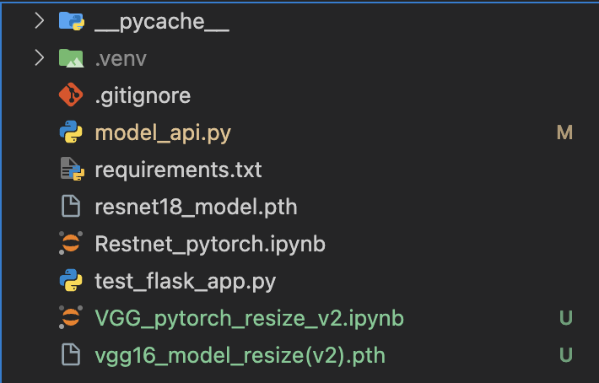
Figure 46: Flask Project Structure

- .venv: This represents a Python virtual environment folder, where dependencies and packages for the project are stored separately from the global Python installation.
- model_api.py: This file contains the code to create an API (Application Programming Interface), using Flask, which allows communication between the machine learning models and external applications such as mobile apps or web platforms. This API is used to handle requests, send predictions from the model, and return results to the client.
- requirements.txt: details the steps to set up the project environment.
- restnet_pytorch.ipynb and VGG_pytorch_resize_v2.ipynb: Jupyter notebooks for ResNet and VGG-16 models in PyTorch.

Structure of the Application

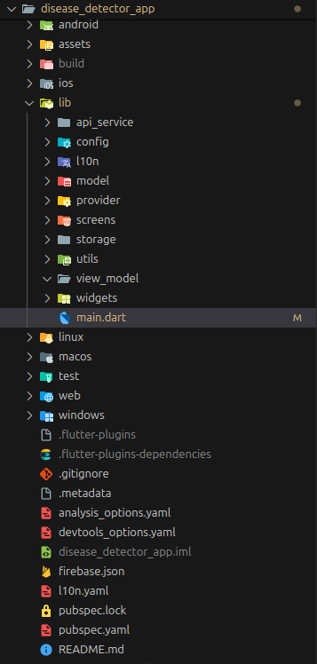
Figure 47: Mobile App Project Structure

- android: The “android” folder contains all the necessary files and configurations specific to Android platform development. It includes essential files like src directory for Java/Kotlin source code, build.gradle for build settings, and AndroidManifest.xml for app metadata. Additionally, it houses Gradle-related files, Flutter integration files, and other project-specific configurations.
- assets: The “assets” folder typically holds various types of static resources, such as images, fonts, and other data files that the application needs during runtime. These assets are bundled with the app when it's built and can be accessed programmatically within Flutter code.

- build: The “build” folder in a Flutter project is automatically generated during the build process and contains various artefacts and intermediate files produced by the build tools. Here's a brief overview that is contained in the build folder: Generated Dart code, Compiled output, Intermediate build artefacts, Cache files, and Temporary files.

- ios: The “ios” folder in a Flutter project houses all the necessary files and configurations for iOS platform development, including the Xcode project file, Swift code, asset catalogues, and Flutterspecific integration files like Generated.xcconfig and Podfile. It's where you manage iOS-specific settings, dependencies, and resources for Flutter app.

- lib: The “lib” folder in a Flutter project is where you primarily develop your app's Dart code. It typically contains the following:

- main.dart: This is the entry point of the application. It initialises the app and defines the main structure. It's where we import libraries, define widgets, and configure the app's behaviour.
- api_service: For storing service to call API or communicate with server.
- Config: Contains base url of the API.
- l10n: This folder contains configuration file for translation language.
- constant: Define the colour, text style, padding, font size to be reusable.
- model: for storing the model file for each data.
- screens: for storing screens of the application.
- provider: for storing provider (type of state management) for each data.
- storage: for storing controllers for saving necessary data to local storage.

- pubspac.yaml: The pubspec.yaml file in a Flutter project is a central configuration file where you define dependencies, metadata, and assets for your app. It specifies the project's name, version, dependencies, assets, and other settings essential for building and running your Flutter app.

After setting up the project, we need to add some packages to be used for the project requirements. And it needs to be added to the pubspec.yaml. After that we need to open the terminal and run “flutter pub get” command for packages to be added. In this project, the needed packages are:
- cupertino_icons: Provides iOS-style icons for use in Flutter applications, giving a more native iOS look.
- iconsax: A collection of customizable icons with different styles that can be used in Flutter apps.
- intl: Provides internationalisation and localization support, including date, time, and number formatting.
- provider: A state management solution that allows for easy and efficient state management and dependency injection in Flutter.
- url_launcher: A package for launching URLs in a mobile platform’s default browser or app, useful for opening web links or external apps.
- flutter_native_splash: Used to create splash screens for Flutter apps, helping to design the app’s startup screen.
- flutter_screenutil: Helps to scale and adapt the UI according to different screen sizes and resolutions.
- fluttertoast: Provides an easy way to show toast messages (short notifications) in Flutter applications.
- shared_preferences: Allows for persistent storage of simple data (e.g., user settings) across app launches.
- smooth_page_indicator: Adds smooth and customizable page indicators (dots) for page view widgets in Flutter.
- dotted_border: A package for drawing a dotted border around widgets, which can be customised for various styles.
- pretty_dio_logger: Provides logging for Dio HTTP requests, offering a more readable and structured log output.
- dio: A powerful HTTP client for Dart, supporting requests, interceptors, and various other features for network communication.
- device_info_plus: Retrieves information about the device (e.g., model, operating system) for various use cases.
- image_picker: Allows for picking images from the gallery or camera in a Flutter application.
- path_provider: Provides access to commonly used locations on the device’s file system (e.g., documents, temporary files).
- flutter_pdfview: A widget for displaying PDF documents in a Flutter app.
- flutter_localization: Provides support for internationalisation and localization of Flutter applications.
- flutter_localizations: Included with Flutter SDK, it provides localizations for Flutter's built-in widgets, supporting multiple languages and regional settings.
- tflite_flutter: is a Flutter plugin that enables running TensorFlow Lite (TFLite) models directly on mobile devices. It provides an easy-to-use interface for loading models, making inferences, and managing TensorFlow Lite interpreters for efficient, on-device machine learning, without requiring internet access.
- tflite_flutter_helper_plus: extends tflite_flutter by offering additional utilities to streamline preprocessing and postprocessing of data for machine learning models. It simplifies tasks such as image manipulation, tensor creation, and label handling, making it easier to integrate TensorFlow Lite models into Flutter apps.
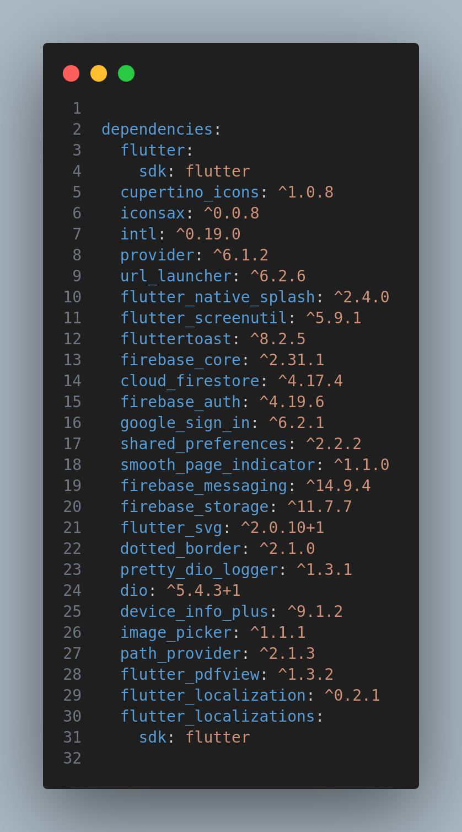
Figure 48: Dependencies of Mobile App

React.js Project
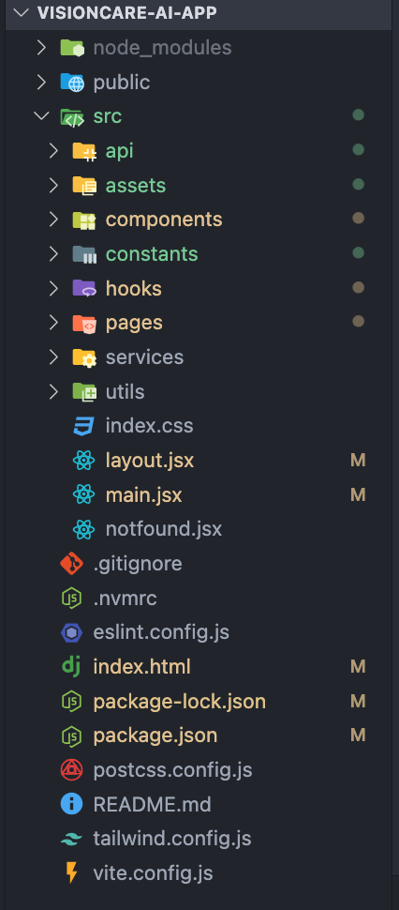
Figure 49: React.js Project Structure

Implementation

API Integration
Integrating a Flask API with a Laravel application involves setting up an HTTP client in Laravel to communicate with the Flask service, handling image uploads, making API requests, and displaying results. Proper error handling and configuration are key to ensuring smooth integration.

API Protection and Security Measures
To ensure the security and integrity of our disease prediction API, several protective measures are implemented:
- Authorization:
  - Token-Based Authentication: The API requires a valid authorization token to be included in the request headers. This token is issued to authenticated users and ensures that only authorised individuals can access the prediction functionalities.
  - Bearer Tokens: Requests must include a Bearer token in the Authorization header, which is validated by the server before processing the request.

    - Risks of Exposed API Endpoints
Even with the above protections, if someone gains knowledge of your API endpoint URL, they could potentially:
- Attempt Unauthorised Access: Without proper security measures, unauthorised users could try to access the API, which might lead to misuse or unauthorised prediction requests.
- Compromise Data Privacy: Exposing endpoints without adequate protection could risk compromising sensitive user data or prediction results.

API Integration
- Appointment Request
API Endpoint:
- URL: /api/appointment-requests
- Method: POST
- Headers: Authorization token required
Request Parameters:
- doctor_id (required): The ID of the doctor (must exist in the doctors' table).
- preferred_date (required): The preferred date for the appointment (in a valid date format).
- phone_number (optional): The user's phone number (string).
Response Details:
- Success:
  - Status Code: 201 Created
  - Returns the appointment request details, including doctor_id, preferred_date, phone_number, request_status.
- Error:
  - Status Code: 400 Bad Request: Validation errors if required fields are missing or invalid.
  - Status Code: 401 Unauthorized: If the user is not authenticated.
Laravel Handling:
- Controller Action: AppointmentRequestController@store
- Authorization: Ensure the request is authenticated using the provided token.
- Data Handling: Validate input data, create a new appointment request with a default status of Pending, and store it in the database.
- Retrieve Doctors
API Endpoint:
- URL: /api/doctors
- Method: GET
- Headers: Authorization token required
Response Details:
- Success: Provides a list of doctors with details including title, first name, last name, specialist, experience, and profile picture URL.
- Error: Information if the user is not authenticated or if there are issues retrieving the doctors.
Laravel Handling:
- Controller Action: DoctorController@index
- Authorization: Ensure the request is authenticated using the provided token.
- Data Retrieval: Fetch and return a list of doctors with the necessary details.
- Prediction API
Prediction Retrieval
API Endpoint:
- URL: http://0.0.0.0:8000/api/predictions
- Method: GET
Response Details:
Success:
[
{
"id": 10,
"user_id": 7,
"predicted_class": "cataract",
"confidence": "0.91",
"created_at": "2024-07-27T17:42:55.000000Z",
"updated_at": "2024-07-27T17:42:55.000000Z",
"image_url": "/storage/images/1722102175.jpg"
}
]
- id: Unique identifier for the prediction record
- user_id: ID of the user who made the prediction
- predicted_class: Classification result from the model
- confidence: Confidence score of the prediction
- created_at: Timestamp when the prediction was created
- updated_at: Timestamp when the prediction was last updated
- image_url: URL to the image associated with the prediction
Laravel Handling:
- Controller Action: PredictionController@index
- Authorization: Ensure the request is authenticated if required.
- Data Retrieval: Fetch and return prediction records from the database.
- Response: Return a JSON array of predictions with relevant details.
Prediction Service
API Endpoint:
- URL: http://0.0.0.0:5000/predict
- Method: POST
Request Details:
Request Body:
{
"Confidence": 0.9191423654556274,
"Image": "cataract_104.jpg",
"Predicted Class": "cataract"
}
- Confidence: Confidence score of the prediction
- Image: Name of the image file associated with the prediction
- Predicted Class: Class label predicted by the model
Response Details:
Success:
{
"Confidence": 0.9191423654556274,
"Image": "cataract_104.jpg",
"Predicted Class": "cataract"
}
- Confidence: The confidence score from the model
- Image: Name of the image file
- Predicted Class: The class label predicted by the model

Mobile Integration

Architecture of Application
The mobile application communicates with the API through a network connection, and the API communicates with the web server through another network connection. The web server stores and manages data used by the mobile application, and the API acts as a middleware layer to manage requests and responses between the mobile application and the web server.

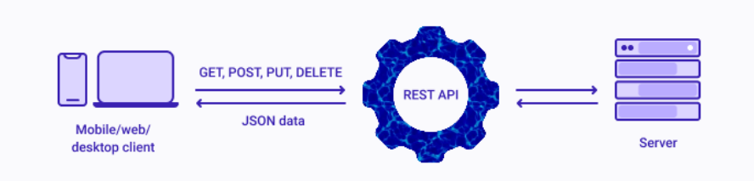
Figure 50: Architecture of Application

Architecture Pattern of Application
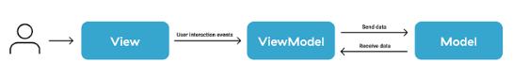
Figure 51: Architecture Pattern of Application
In our project, we use MVVM architecture to build. MVVM architecture (ModelView-ViewModel) is the software design pattern that separates the graphical user interface from the business logic of an application.

- Model: The model represents the app’s domain model, which can include a data model as well as business and validation logic. It communicates with the ViewModel, and lacks awareness of the View.
- View: The View represents the user interface of the application and holds limited, purely presentational logic that implements visual behaviour. The View is completely agnostic to the business logic. In other words, the View is a “dumb” class that never contains data, nor manipulates it directly.It communicates with the ViewModel through data binding and is unaware of the Model.
- ViewModel: The ViewModel is the link between the View and the Model. It implements and exposes public properties and commands that the View uses by way of data binding. If any state changes occur, the ViewModel notifies the View through notification events.

Web Client Integration

Architecture of Web Application
- Client (React.js): This is typically the front end, Visioncare AI App. The client is responsible for presenting the user interface and sending requests to the server through the REST API. For example, Visioncare AI app sends requests to detect eye diseases by uploading images.
- REST API: The REST (Representational State Transfer) API is the intermediary layer between the client and the server (React.js and Lavael, FlaskAPI). It receives HTTP requests from the client, processes these requests, and then communicates with the server to fetch or modify data.
- Server (Laravel, FlaskAPI): The server is where the backend logic resides. It processes the requests sent by the API, interacts with the database, and returns the appropriate data or response. For example, when the Visioncare AI App sends an image for eye disease detection, the server could run machine learning models on the image to provide a diagnosis.
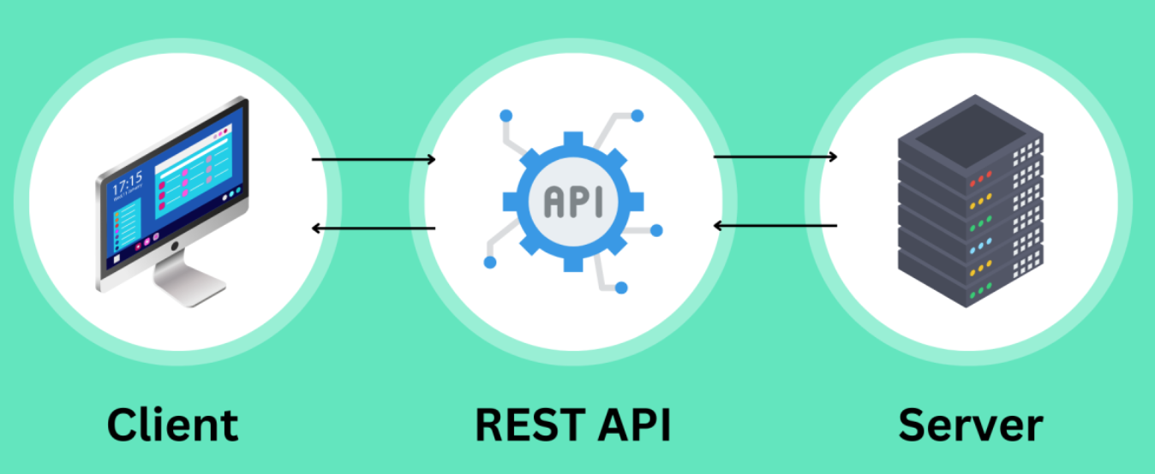
Figure 52: Architecture of Web Application

Conclusion

Result
With the time constraint, there are completed functionalities in the system
and are some of the uncompleted functionalities but the system is finally can be
used on the main functionality such as:

Feature |  | Description | Status
Mobile App | Network connection Handling | Check network status and handle it when the status offline or online | Completed
Mobile App | Predict Disease on Offline Mode | Allow User to Predict their eye disease for offline mode | Completed
Mobile App | View detail information of clinics and doctors | View detailed information such as location of clinic, specialist, doctor, experiences also. | Completed
Mobile App | Book Appointment with doctor | User can book an appointment with doctor that they want, and users required to select date and their information also, when book success user will wait the approvement from the doctor (Dashboard). | Completed
Mobile App | Enhance App Theme | Update some UI to be look better and change colour and font of the app | Completed
Website (Clinic) | View Dashboard | clinic can access to dashboard that provides an overview of total number of doctors, admitted patients and readmitted patients | Completed
Website (Clinic) | Mange Doctor | Clinic can manage doctor profiles by add, update and delete | Completed
Website (Clinic) | Respond to Appointment Request | Clinic can handle appointment requests by either accepting or rejecting the request | Completed
Website (User) | Authentication | Implement secure user authentication allowing users to sign in using their email and password. | Completed
Website (User) | User Registration | Users can register by providing first name, last name, phone number, email, and a profile image | Completed
Website (User) | Reset Password | Allow users to reset their password in case they forgot the password | Completed
Website (User) | Edit User Profile | Users can edit their information, including name, phone number, email, and profile image | Completed
Website (User) | Dark/Light Theme | Users can switch to light mode or dark mode | Completed
Website (User) | Visioncare News Section | Display a news section that pulls in the latest articles or updates related to eye care, eye health, and advancements in vision care technology | Completed
Website (User) | AI Disease Detection | Provide an interface where users can upload an image of their eye. The image will be analysed by the AI-powered detection system to identify potential eye diseases | Completed
Website (User) | AI Detect Incorrect Image | The AI can validate the images that users upload. If the image is not of an eye, it cannot detect any diseases | Completed
Website (User) | Save/Delete AI Detection History | Users can save or delete their eyes detection result | Completed
Website (User) | Send Email | users can send emails directly to the website for support | Completed

Table 15: Completed Task Table

However, we haven’t complete some tasks also such as:
Task | Status
Collect large amounts of data in Cambodia. | Uncompleted
Switch Language to khmer in website | Uncompleted
Table 16: Uncompleted Task Table

Strong Points
After developing this project, I have identified some strong points in the system, including:
- Has many features including Disease Detection, saving results to history and an admin panel to manage the overall app.
- User-friendly and can provide a seamless experience for users of all ages.
- Classify 3 classes including Cataracts, Diabetic Retinopathy, and Normal Eye.
- Users can potentially save money on frequent visits to healthcare providers

Weak Points
While the system has many strong points, there are still areas that need improvement, including:
- The system still needs more features to improve
- Cannot predict well on unseen data due to we have only a small dataset.
- Ensuring the accuracy of the image classification models is crucial to avoid

Experiences
After implemented this project, We gained experience in:
- Understand more about machine learning
- Improved both hard and soft skills
- Increased responsibility with work
- Improved researching skills

Difficulties
During our development on this project, We encountered some difficulties including:
- Misunderstanding project requirement
- Spend a lot of time learning new technology. Ex: flutter, building API, training model
- Understanding the concept of each technology
- Image classification is the new method that we never worked on before.

Perspective
If given more time to work on this project, We would prioritise improving certain tasks that we didn't have the chance to complete. These include:
- Improve UX and UI
- Add more feature and functionalities
- We want to get more data and if we can get the real data from the Khmer hospitals it will improve our model to apply in Cambodia.
- Enhanced Security To further protect Our API and mitigate potential risks, consider implementing the following additional security measures:
IP Whitelisting:
  - Restrict API access to a predefined list of IP addresses or ranges to limit who can make requests.
OAuth 2.0:
  - Implement OAuth 2.0 for robust authorization management. This standard protocol enhances security by managing access tokens more securely.
API Gateway:
  - Use an API gateway to manage traffic, enforce additional security policies, and monitor API usage. The gateway can provide features such as request throttling and IP filtering.

Conclusion
In conclusion, this project is much more than just an application; it's a meaningful learning and development experience. We have improved our technical skills and learnt important lessons that go beyond the project's immediate objectives during this process. Every challenge has been a chance for creativity, and every victory helped strengthen our commitment and collaboration. In addition to sharpening our abilities, the experience has strengthened our bond as a group and prepared us to take on new challenges with confidence and energy. We thank everyone who has helped and advised us as we come to the end of this stage of our journey. We're eager to use what we've discovered to further our success in the future.

REFERENCES
[1] Dataset for different eye diseases. (n.d.). Kaggle: Your Machine Learning and Data Science Community.
https://www.kaggle.com/datasets/dhirajmwagh1111/dataset-for-different-eye-disease
[2] Eye_diseases_classification. (n.d.). Kaggle: Your Machine Learning and Data Science Community.
https://www.kaggle.com/datasets/gunavenkatdoddi/eye-diseases-classification
[3] A global review of publicly available datasets for ophthalmological imaging: barriers to access, usability, and generalisability. (2020, October 1). The Lancet Digital Health. https://www.thelancet.com/journals/landig/article/PIIS2589-7500(20)30240-5/fulltext
[4] VGG-16 | CNN model. (2024, March 21). GeeksforGeeks.
https://www.geeksforgeeks.org/vgg-16-cnn-model/
[5] Nabi, J. (2019, March 16). Hyper-parameter Tuning Techniques in Deep Learning. Medium. https://towardsdatascience.com/hyper-parameter-tuning-techniques-in-deep-learning-4dad592c63c8
[6] Persson, A. (2023, April 15). Machine Learning Collection. GitHub. https://github.com/aladdinpersson/Machine-Learning-Collection
[7] 154 - Understanding the training and validation loss curves. (n.d.). Www.youtube.com. https://www.youtube.com/watch?v=p3CcfIjycBA
[8] Image Classification Using Pytorch and Convolutional Neural Network. (n.d.). Www.youtube.com. https://www.youtube.com/watch?v=cJpwQJp9flU
[9] Kundu, N. (2023, January 23). Exploring ResNet50: An In-Depth Look at the Model Architecture and Code Implementation. Medium. https://medium.com/@nitishkundu1993/exploring-resnet50-an-in-depth-look-at-the-model-architecture-and-code-implementation-d8d8fa67e46f
[10] Gao X, Lin S, Wong TY. Automatic feature learning to grade nuclear cataracts based on deep learning. IEEE Trans Biomed Eng. 2015;62(11):2693–2701. [PubMed] [Google Scholar]
[11] Li Z, He Y, Keel S, Meng W, Chang RT, He M. Efficacy of a deep learning system for detecting glaucomatous optic neuropathy based on colour fundus photographs. Ophthalmology. 2018; 125: 1199–1206.
[12] Kermany, D.S., Kermany, D.S., Goldbaum, M.H., Cai, W., Valentim, C.C., Liang, H., Baxter, S.L., McKeown, A., Yang, G., Wu, X., Yan, F., Dong, J., Prasadha, M.K., Pei, J., Pei, J., Ting, M.Y., Zhu, J., Li, C.M., Hewett, S., Hewett, S., Dong, J., Ziyar, I., Shi, A., Zhang, R., Zheng, L., Hou, R., Shi, W., Fu, X., Fu, X., Duan, Y., Huu, V.A., Huu, V.A., Wen, C., Zhang, E., Zhang, E., Zhang, C.L., Zhang, C.L., Li, O., Li, O., Wang, X., Singer, M.A., Sun, X., Xu, J., Tafreshi, A.R., Lewis, M.A., Xia, H., & Zhang, K. (2018). Identifying Medical Diagnoses and Treatable Diseases by Image-Based Deep Learning. Cell, 172, 1122-1131.e9.

APPENDICES

